

**CSE 227**

**Database Systems (1)**

Submitted by:

Basma Magdy Mohamed 16P8187

Youssef Ossama Eid 16P8178

Ahmed Bahaa Ibrahim 16P6057

Amr Mohamed ElSayed

Menna Alaa

Mohamed Hesham

Submitted to:

Dr/ Hoda Korashy

Project Description:

This database models the domain of a hyper market which has:

* Departments which have a name, and a unique ID.
* Employees each has first name, last name, unique SSN, salary, sex and may be more than one telephone number.
* An Employee can be a Cashier, a Shop Assistant, or a Driver.
* Cashiers have a single attribute called window number.
* Shop Assistants roam certain halls, these halls are saved as attributes.
* Drivers must have a driving license as an attribute.
* Products have name, quality, price and unique product ID.
* Suppliers have unique ID, name and balance which has credit and debit sides.
* Orders have order date, supply date, payment and unique order number.
* Customers have first name, last name, may have multiple card numbers, address, unique customer ID and phone number.
* Vehicles have unique plate number and used flag
* Vehicles may be bus , car or truck
* Car has single attribute called order area
* Bus has single attribute called passenger#
* Truck has single attribute called tonnage

Relations

* Employees must work in a department and a department contains many employees.
* Each department must contain employees.
* Each department must have an employee that managers it and each manager manages one department.
* Some employees take the bus each bus must transport employees.
* Each Driver must drive a vehicle, a vehicle can sometimes have no drivers in charge of it.
* Products must have a department but not each department must have products in them all the time.
* Each product must be shipped by a truck and trucks ship many kinds of products.
* Each Orders must contain products and many products must be included in one order.
* Customer may make many order but each order must have a customer.
* Many products must be supplied by supplier and each supplier must supply many products.

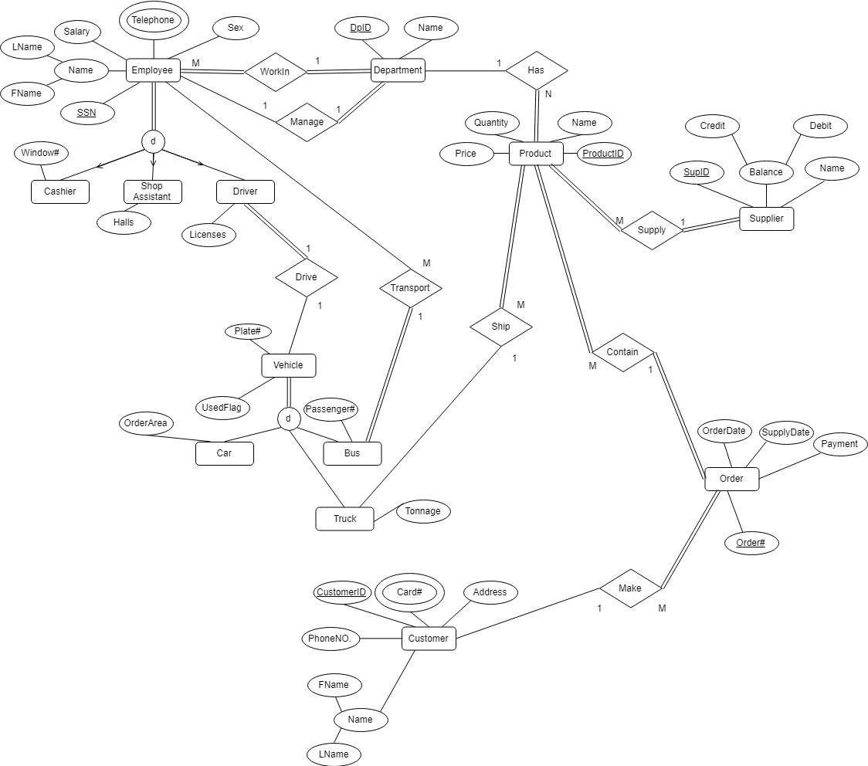EER Diagram:

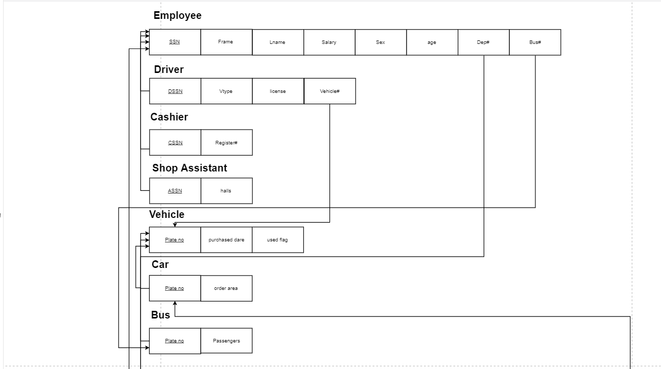Relational Schema:

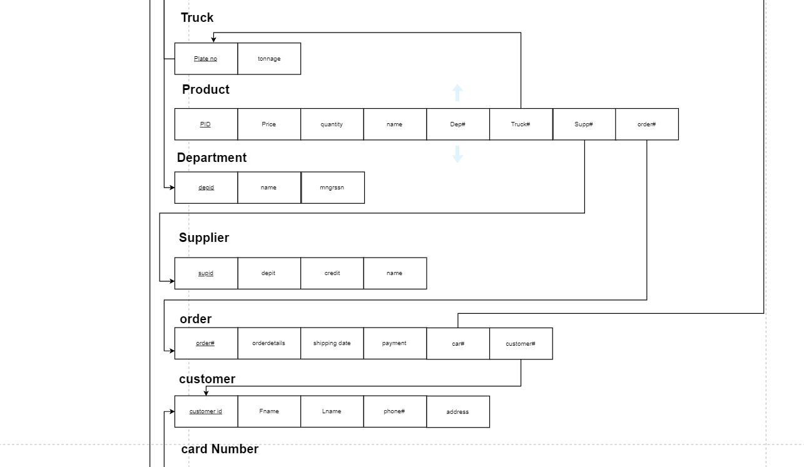

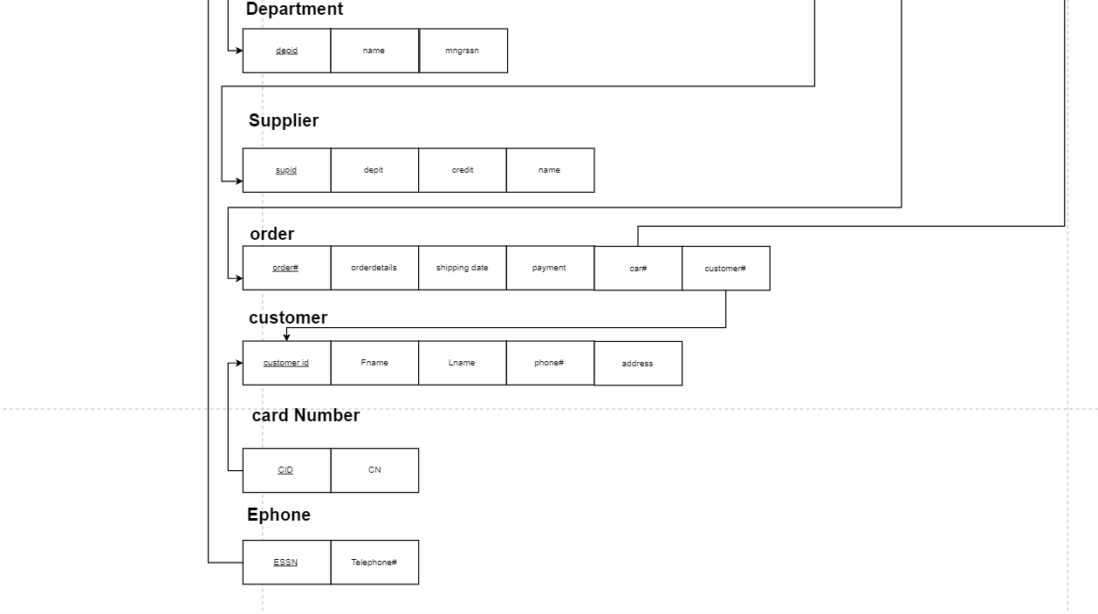

Create Commands:

CREATE TABLE Driver (

DSSN CHAR(9) NOT NULL,

VTYPE VARCHAR(10) NOT NULL,

LISCESNCE CHAR(10) NOT NULL,

VEHICLENUMBER CHAR(4) NOT NULL,

PRIMARY KEY (DSSN),

FOREIGN KEY (VEHICLENUMBER) REFERENCES VEHICLE(PLatenumber)

ON DELETE RESTRICT

ON UPDATE CASCADE

);

CREATE TABLE CASHIER(

CSSN CHAR(9) NOT NULL,

REGISTERNUMBER VARCHAR(2) NOT NULL,

PRIMARY KEY (CSSN),

FOREIGN KEY (CSSN) REFERENCES EMPLOYEE(SSN)

ON DELETE RESTRICT

ON UPDATE CASCADE

);

CREATE TABLE SHOPASSISTANT(

ASSN CHAR(9) NOT NULL,

HALLS CHAR(2) NOT NULL,

PRIMARY KEY (ASSN),

FOREIGN KEY (ASSN) REFERENCES EMPLOYEE(SSN)

ON DELETE RESTRICT

ON UPDATE CASCADE

);

CREATE TABLE VEHICLE(

PLatenumber CHAR(4) NOT NULL,

purshesdate DATE NOT NULL,

usedflag CHAR(1) NOT NULL,

PRIMARY KEY (PLatenumber)

);

CREATE TABLE CAR(

PLatenumber CHAR(4) NOT NULL,

ORDERAREA VARCHAR(5) NOT NULL,

PRIMARY KEY (PLatenumber),

FOREIGN KEY (PLatenumber) REFERENCES VEHICLE(PLatenumber)

ON DELETE RESTRICT

ON UPDATE CASCADE

);

CREATE TABLE BUS(

PLatenumber CHAR(4) NOT NULL,

PASSENGERS INT(2) NOT NULL,

PRIMARY KEY (PLatenumber),

FOREIGN KEY (PLatenumber) REFERENCES VEHICLE(PLatenumber)

ON DELETE RESTRICT

ON UPDATE CASCADE

);

CREATE TABLE TRUCK(

PLatenumber CHAR(4) NOT NULL,

TONNAGE INT(3) NOT NULL,

PRIMARY KEY (PLatenumber),

FOREIGN KEY (PLatenumber) REFERENCES VEHICLE(PLatenumber)

ON DELETE RESTRICT

ON UPDATE CASCADE

);

CREATE TABLE EPHONE(

ESSN CHAR(9) NOT NULL,

TELEPHONENUMBER CHAR(11) NOT NULL,

PRIMARY KEY (ESSN),

FOREIGN KEY (ESSN) REFERENCES EMPLOYEE(SSN)

ON DELETE RESTRICT

ON UPDATE CASCADE

);

CREATE TABLE EMPLOYEE (

SSN CHAR(9) NOT NULL,

FNAME VARCHAR(10) NOT NULL,

LNAME VARCHAR(10) NOT NULL,

SALARY INTEGER(11),

SEX CHAR(1) NOT NULL,

DATE_OF_BIRTH DATE NOT NULL,

DEPARTMENTNO INTEGER(2),

BUSNO CHAR(4),

PRIMARY KEY(SSN),

FOREIGN KEY(DEPARTMENTNO) REFERENCES DEPARTMENT(DEPARTMENT_ID)

ON DELETE RESTRICT

ON UPDATE CASCADE,

FOREIGN KEY(BUSNO) REFERENCES BUS(Platenumber)

ON DELETE RESTRICT

ON UPDATE CASCADE

);

CREATE TABLE DEPARTMENT (

DEPARTMENT_ID INTEGER(2) NOT NULL,

DNAME VARCHAR(10) NOT NULL,

MGRSSN CHAR(9),

PRIMARY KEY (DEPARTMENT_ID),

FOREIGN KEY (MGRSSN) REFERENCES EMPLOYEE (SSN)

ON DELETE RESTRICT

ON UPDATE CASCADE

);

CREATE TABLE PRODUCT (

PRODUCT_ID CHAR(4) NOT NULL ,

PRICE INTEGER(6) ,

QUANTITY INTEGER(2),

PNAME VARCHAR(10) NOT NULL,

DEPARTMENTNO INTEGER(2),

TRUCKNO CHAR(4) NOT NULL,

SUPPLIERNO CHAR(4),

ORDERNO CHAR(4),

PRIMARY KEY (PRODUCT_ID),

FOREIGN KEY (DEPARTMENTNO) REFERENCES DEPARTMENT(DEPARTMENT_ID)

ON DELETE RESTRICT

ON UPDATE CASCADE,

FOREIGN KEY (TRUCKNO) REFERENCES TRUCK(PLatenumber)

ON DELETE RESTRICT

ON UPDATE CASCADE,

FOREIGN KEY (SUPPLIERNO) REFERENCES SUPPLIER(SUPPLIER_ID)

ON DELETE RESTRICT

ON UPDATE CASCADE,

FOREIGN KEY (ORDERNO) REFERENCES ORDERS (ORDERNo)

ON DELETE RESTRICT

ON UPDATE CASCADE);

CREATE TABLE SUPPLIER (

SUPPLIER_ID CHAR(4) NOT NULL,

DEBIT INTEGER(11),

CREDIT INTEGER(11),

SNAME VARCHAR(10) NOT NULL,

PRIMARY KEY(SUPPLIER_ID));

CREATE TABLE ORDERS(

ORDERNo CHAR(4) NOT NULL,

ORDER_DATE DATE,

SHIPPING_DATE DATE,

PAYMENT INTEGER(11),

CARNo CHAR(4),

CUSTOMERNo CHAR(9),

PRIMARY KEY(ORDERNo),

FOREIGN KEY (CARNo) REFERENCES CAR(PLatenumber)

ON DELETE RESTRICT

ON UPDATE CASCADE,

FOREIGN KEY (CUSTOMERNo) REFERENCES CUSTOMER (CUSTOMER_ID)

ON DELETE RESTRICT

ON UPDATE CASCADE

);

CREATE TABLE CUSTOMER (

CUSTOMER_ID CHAR(9) NOT NULL,

FNAME VARCHAR(10) NOT NULL,

LNAME VARCHAR(10) NOT NULL,

PHONENo CHAR(11) ,

ADDRESS VARCHAR(50),

PRIMARY KEY(CUSTOMER_ID));

CREATE TABLE CARD_NUMBER(

CID CHAR(9) NOT NULL,

CARDNo CHAR(9) ,

PRIMARY KEY (CID,CARDNo),

FOREIGN KEY (CID) REFERENCES CUSTOMER(CUSTOMER_ID)

ON DELETE RESTRICT

ON UPDATE CASCADE);

Insert Commands:

INSERT INTO EMPLOYEE VALUES ("970736010","Yousef","Hamad",10000,"m","1998-07-25",5,"1234");

INSERT INTO EMPLOYEE VALUES ("548763855","Ahmed","Bahaa",18000,"m","1998-02-15",3,"1235");

INSERT INTO EMPLOYEE VALUES ("654987543","Youssef","Ossama",1000000,"m","1999-06-01",1,null);

INSERT INTO EMPLOYEE VALUES ("654654582","Youssef","magdy",1000,"m","1999-06-01",1,"1234");

INSERT INTO EMPLOYEE VALUES ("446778899","Amr","Badawi",1000,"m","1998-09-27",3,null);

INSERT INTO EMPLOYEE VALUES ("654689879","Basma","Hassan",500,"f","1998-05-12",4,"1235");

INSERT INTO EMPLOYEE VALUES ("654654987","Menna","Naiem",500,"f","1998-03-17",4,"1231");

INSERT INTO EMPLOYEE VALUES ("970725010","Mohamed","Hisham",100,"m","1996-07-25",4,"1231");

INSERT INTO EMPLOYEE VALUES ("564698798","Mohamed","hassan",300,"m","1996-07-25",2,"1234");

INSERT INTO EMPLOYEE VALUES ("564648489","Mohamed","ahmed",300,"m","1996-07-25",2,"1235");

INSERT INTO EMPLOYEE VALUES ("654687979","Mohamed","bahaa",300,"m","1996-07-25",2,"1232");

INSERT INTO department VALUES (1,"Accounting","446778899");

INSERT INTO department VALUES (2,"Transport","548763855");

INSERT INTO department VALUES (3,"Electric","654689879");

INSERT INTO department VALUES (4,"Bakery","970725010");

INSERT INTO department VALUES (5,"Marketing","654654987");

insert into cashier values ("654987543","1");

insert into cashier values ("654654582","2");

#buses#

insert into vehicle values("1234","2001-03-01","1");

insert into vehicle values("1233","2002-02-03","0");

insert into vehicle values("1232","2004-02-03","1");

insert into vehicle values("1231","2005-02-03","0");

insert into vehicle values("1235","2003-02-03","0");

#trucks#

insert into vehicle values("1222","2005-02-03","1");

insert into vehicle values("1223","2003-02-03","1");

#car#

insert into vehicle values("1322","2005-02-03","0");

insert into vehicle values("1321","2003-02-03","1");

#truckinsert#

insert into truck values("1222","1");

insert into truck values("1223","2");

#businsert#

insert into bus values("1234","12");

insert into bus values("1233","15");

insert into bus values("1232","15");

insert into bus values("1231","10");

insert into bus values("1235","10");

#carinsert#

insert into car values("1322","Cairo");

insert into car values("1321","GIZA");

INSERT INTO ephone VALUES ("548763855","01037156378");

INSERT INTO ephone VALUES ("654987543","01182762876");

INSERT INTO ephone VALUES ("446778899","01183657893");

INSERT INTO ephone VALUES ("654689879","01293863526");

INSERT INTO ephone VALUES ("654654987","01193873657");

INSERT INTO ephone VALUES ("970725010","01003938725");

INSERT INTO ephone VALUES ("564698798","01029374567");

INSERT INTO ephone VALUES ("564648489","01000283656");

INSERT INTO ephone VALUES ("654687979","01012038646");

INSERT INTO ephone VALUES ("654654582","01012038782");

INSERT INTO ephone VALUES ("970736010","01012038782");

INSERT INTO driver VALUES ("564698798","Car","2851489875","1321");

INSERT INTO driver VALUES ("564648489","Truck","2851489848","1222");

INSERT INTO driver VALUES ("654687979","Bus","2848989325","1231");

INSERT INTO shopassistant VALUES ("654654987","01");

INSERT INTO shopassistant VALUES ("654689879","02");

INSERT INTO shopassistant VALUES ("548763855","03");

INSERT INTO shopassistant VALUES ("446778899","04");

INSERT INTO customer VALUES ("123498765","El-Sayed","Badawi","01060406251","New Cairo");

INSERT INTO customer VALUES ("123498900","Ahmed","Gomaa","01063406651","Nasr City");

INSERT INTO customer VALUES ("123498100","Mostafa","Osama","01177406251","Mokattam");

INSERT INTO customer VALUES ("123498300","Mahmoud","Magdy","01250406251","Nozha");

INSERT INTO card_number VALUES ("123498765","965437812");

INSERT INTO card_number VALUES ("123498765","585437812");

INSERT INTO card_number VALUES ("123498900","756212358");

INSERT INTO card_number VALUES ("123498100","965214635");

INSERT INTO card_number VALUES ("123498300","354187625");

insert into supplier VALUES("4564",500000,1000000,"elhuda");

insert into supplier VALUES("8795",65200,20000,"elfath");

insert into supplier VALUES("9876",23000,3000,"alkuds");

insert into supplier VALUES("6549",405,700000,"alragaa");

INSERT INTO product VALUES ("1967",4000,20,"Microwave",3,"1222","4564","8798");

INSERT INTO product VALUES ("1732",250,10,"Cake",4,"1223","8795","9875");

INSERT INTO product VALUES ("1847",7000,15,"Heater",3,"1223","9876","3944");

INSERT INTO product VALUES ("2937",20,40,"Toast",4,"1222","6549","9928");

insert into orders VALUES("8798","2019-05-07","2019-05-09",500,"1322","123498765");

insert into orders VALUES("9875","2019-05-07","2019-06-01",6000,"1322","123498900");

insert into orders VALUES("5556","2019-06-08","2019-09-09",300,"1322","123498100");

insert into orders VALUES("3944","2019-07-09","2019-08-08",700,"1322","123498300");

insert into orders VALUES("3948","2019-05-05","2019-07-02",1000,"1322","123498100");

insert into orders VALUES("9928","2019-06-04","2019-08-04",400,"1322","123498765");

Update Commands:

UPDATE EMPLOYEE SET salary = salary *1.2 WHERE DEPARTMENTNO IN (SELECT DEPARTMENT_ID FROM DEPARTMENT WHERE DNAME="Transport");

UPDATE VEHICLE SET PLatenumber = "7777" WHERE PLatenumber = "1234";

UPDATE DEPARTMENT SET DNAME="Sales" WHERE DEPARTMENT_ID=1;

UPDATE CUSTOMER SET LNAME = "Samy" WHERE CUSTOMER_ID = "123498900";

UPDATE PRODUCT SET PRICE = 10000 WHERE PRODUCT_ID = "1847";

Delete Commands:

DELETE FROM EMPLOYEE WHERE SSN="654689879";

DELETE FROM DEPARTMENT WHERE DEPARTMENT_ID=3;

DELETE FROM VEHICLE WHERE PLatenumber="1233";

DELETE FROM CUSTOMER WHERE CUSTOMER_ID="123498765";

DELETE FROM PRODUCT WHERE PRODUCT_ID="1967";

Query Commands:

#1.getting employee names ,ids and bdate working in the department -transport- #

Create view EMP_TRANS AS (

SELECT FNAME , LNAME, SSN, DATE_OF_BIRTH

FROM EMPLOYEE,DEPARTMENT

WHERE DEPARTMENTNO=DEPARTMENT_ID AND DNAME = "Transport"

);

#2.getting employees names , ids taking bus no 1235 #

Create view Emp_1235 AS(

SELECT FNAME , LNAME, SSN

FROM EMPLOYEE

WHERE BUSNO = "1235" ;

);

#3.getting Orders no date ship date for customer Lastname Badawi #

Create view Orders_Badawi AS (

SELECT ORDERNo , ORDER_DATE , SHIPPING_DATE

FROM ORDERS , CUSTOMER

WHERE CUSTOMERNo = CUSTOMER_ID AND LNAME = "Badawi";

);

#4.getting name of supplier who supplies the product "Microwave" #

Create view SNAME_Microwave AS (

SELECT SNAME

FROM SUPPLIER , PRODUCT

WHERE SUPPLIERNO = SUPPLIER_ID AND PNAME = "Microwave";

);

#5.name, id , salary of the shopassistant which works in hall 02 #

Create view SHOP_02 AS (

SELECT FNAME , LNAME, SSN ,SALARY

FROM EMPLOYEE , SHOPASSISTANT

WHERE SSN = ASSN AND HALLS = "02"

);

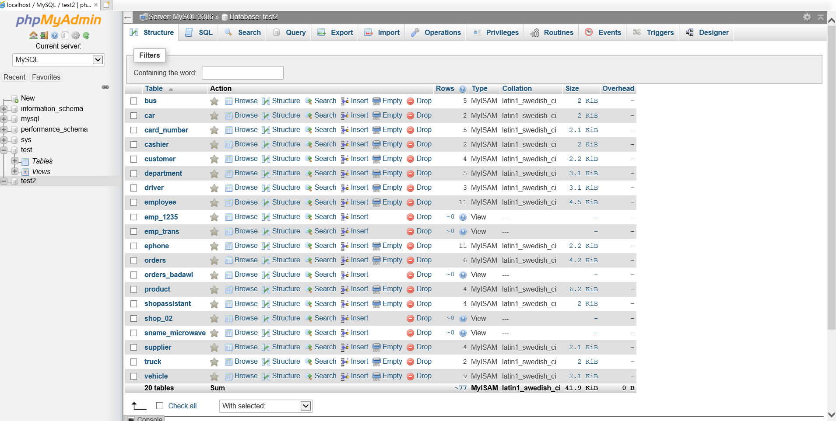Table Screenshots:

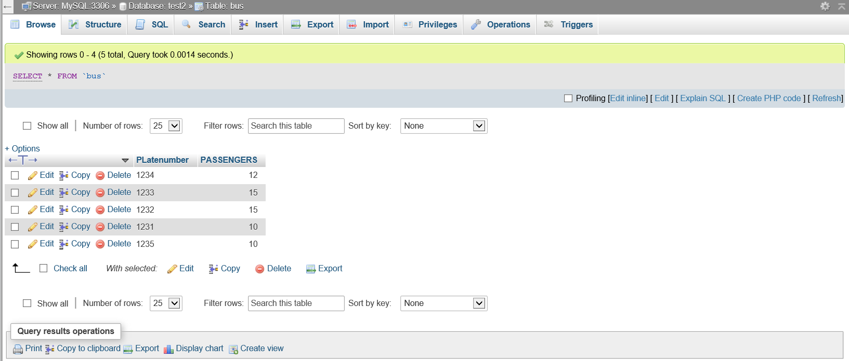

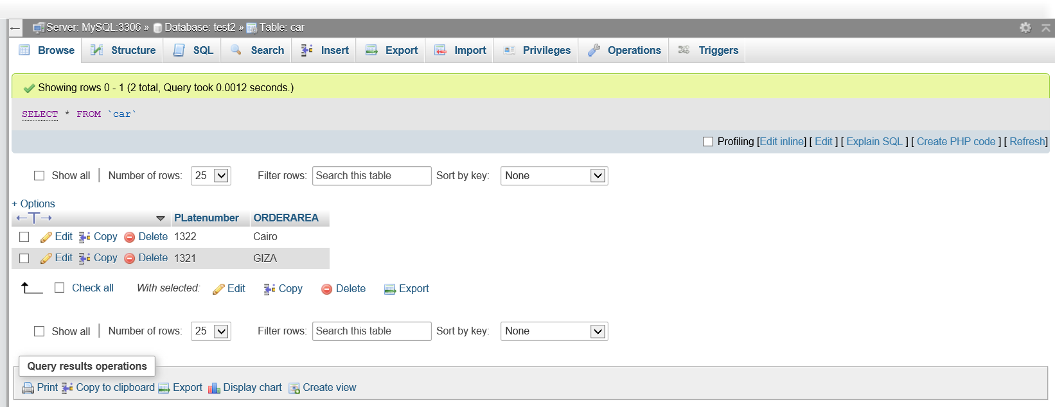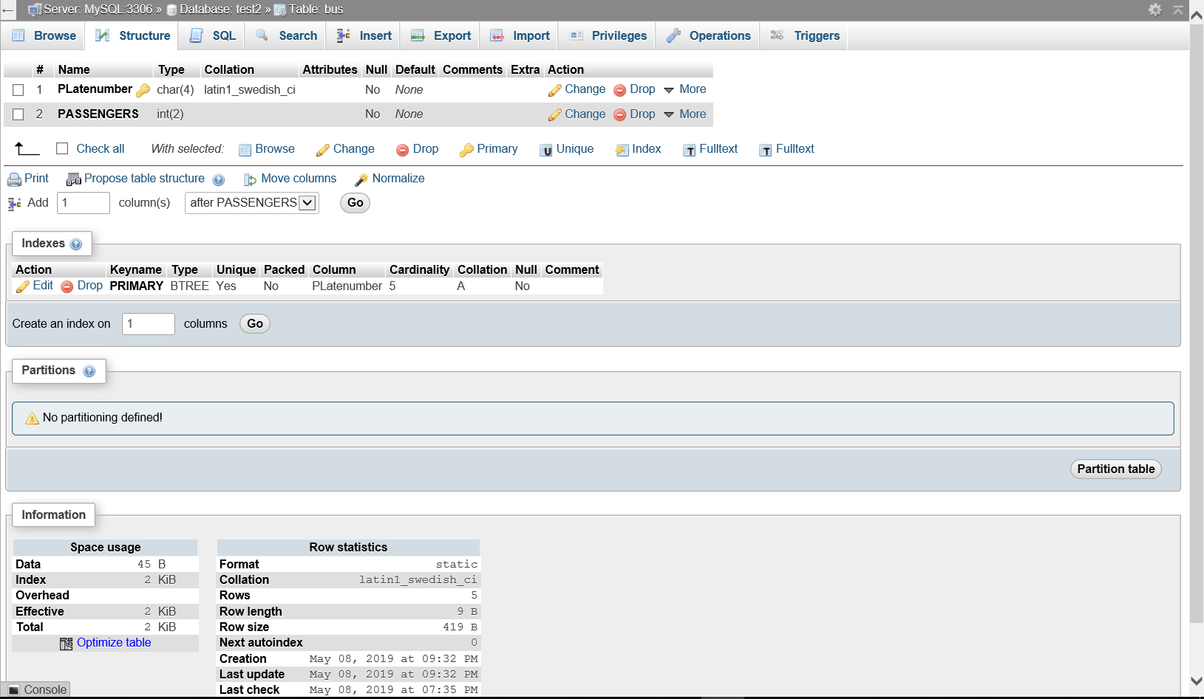

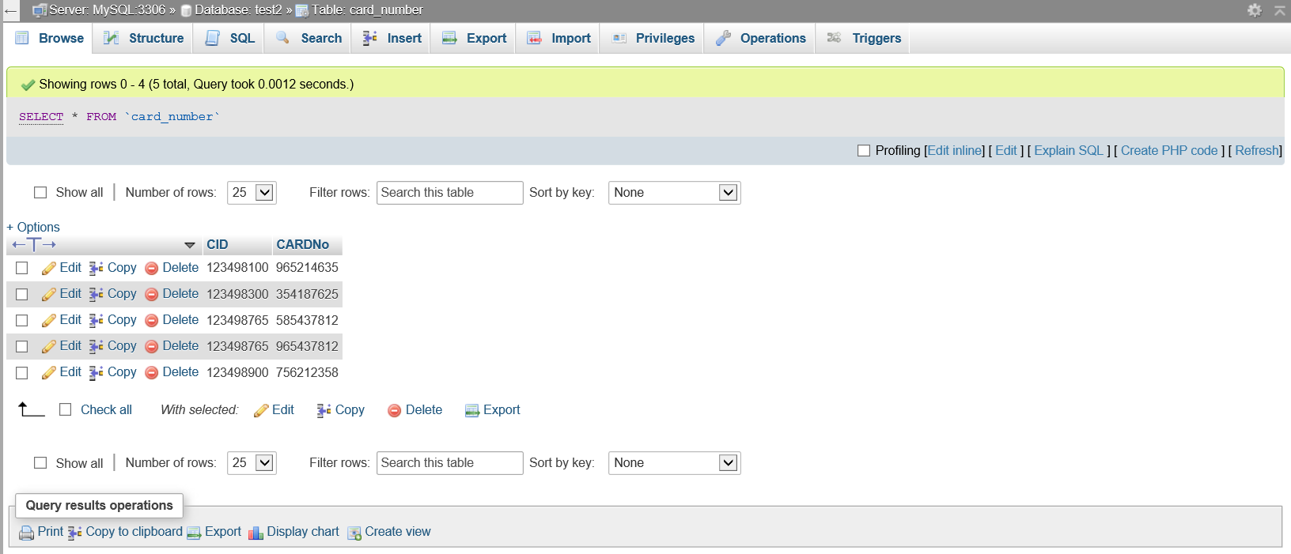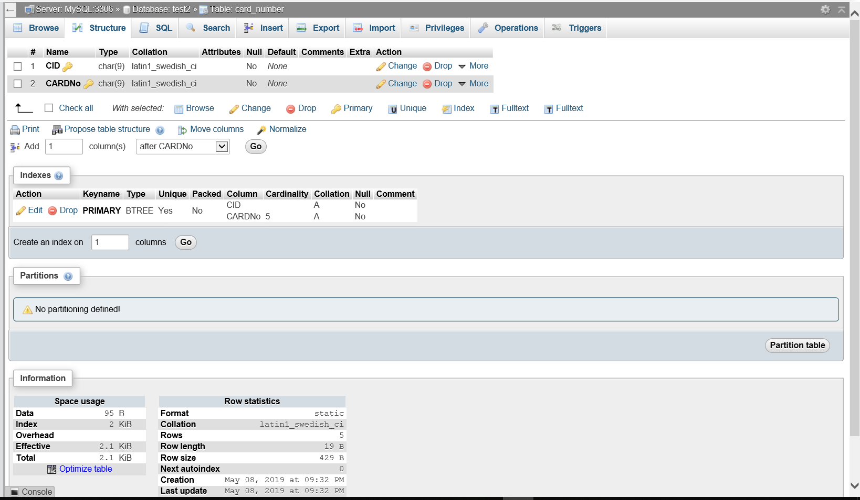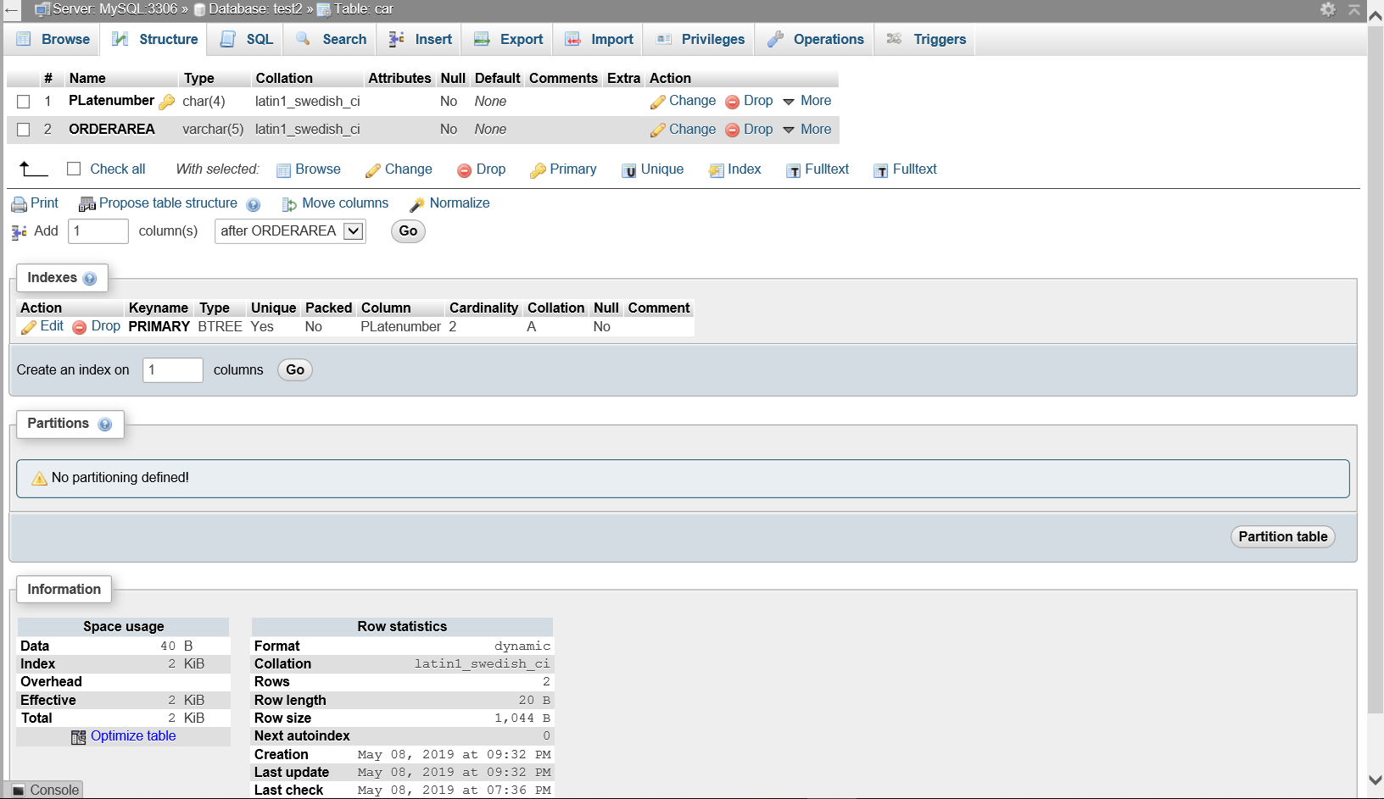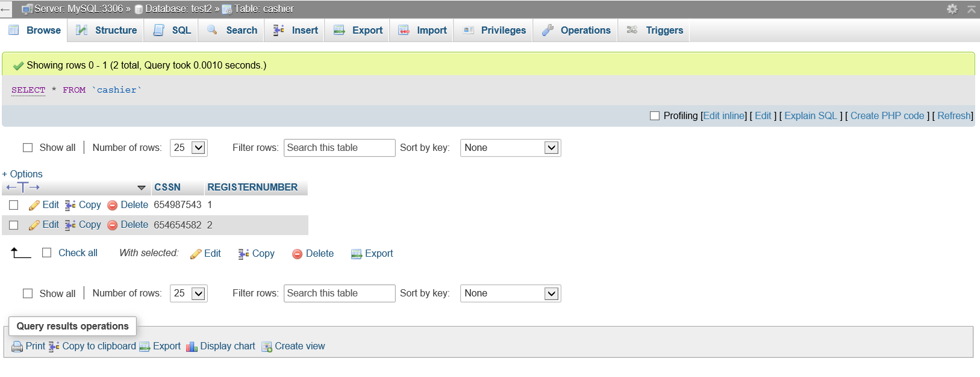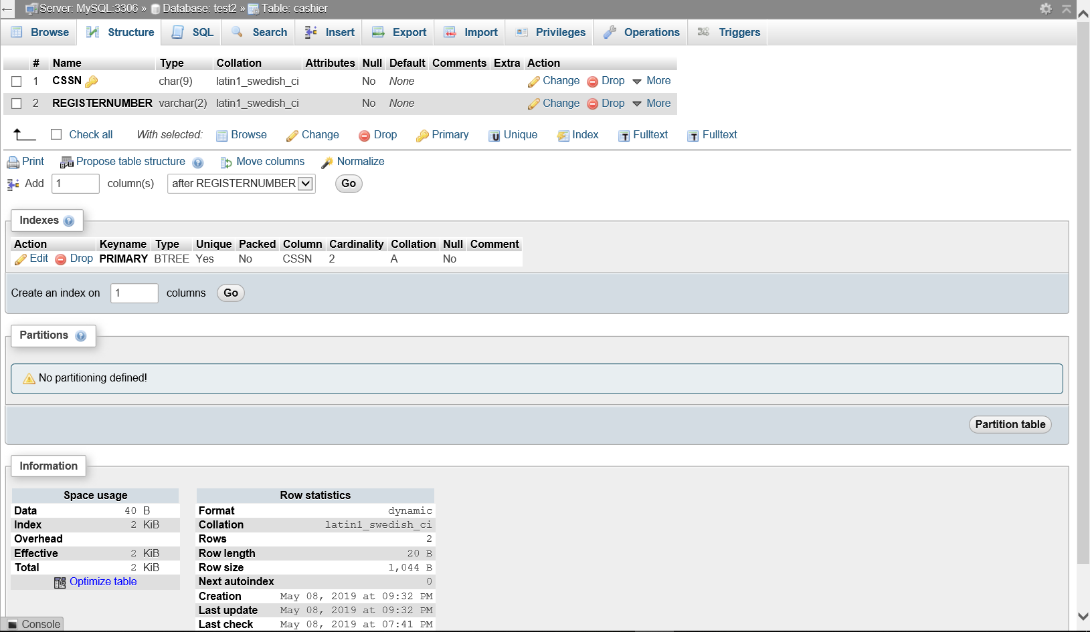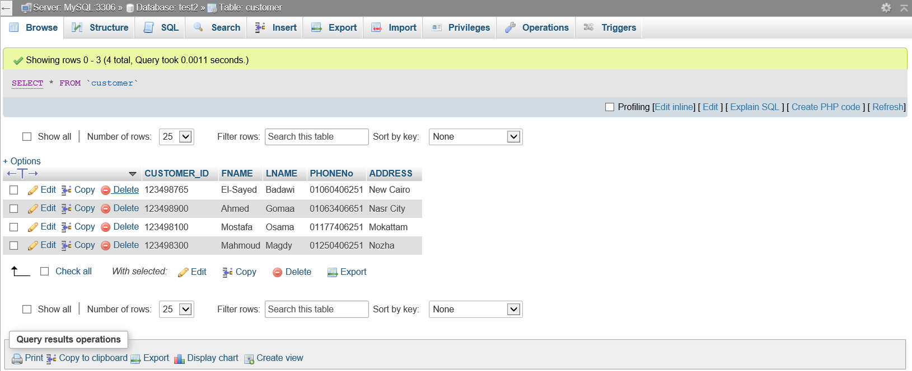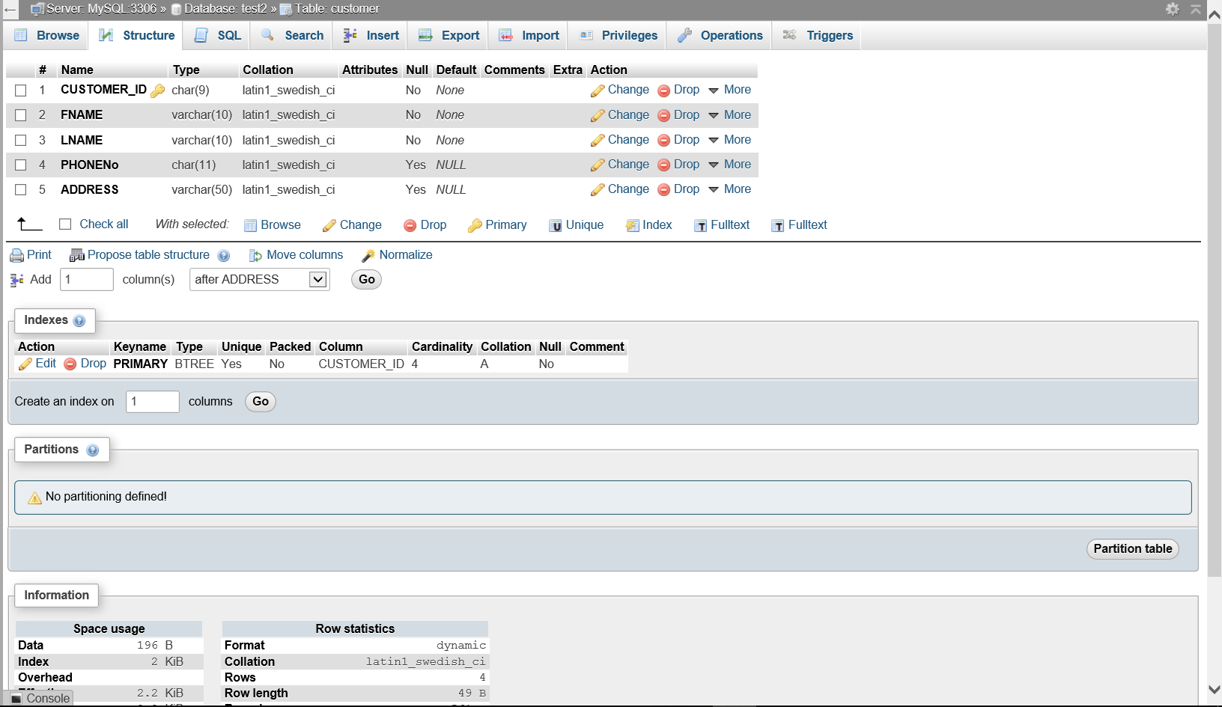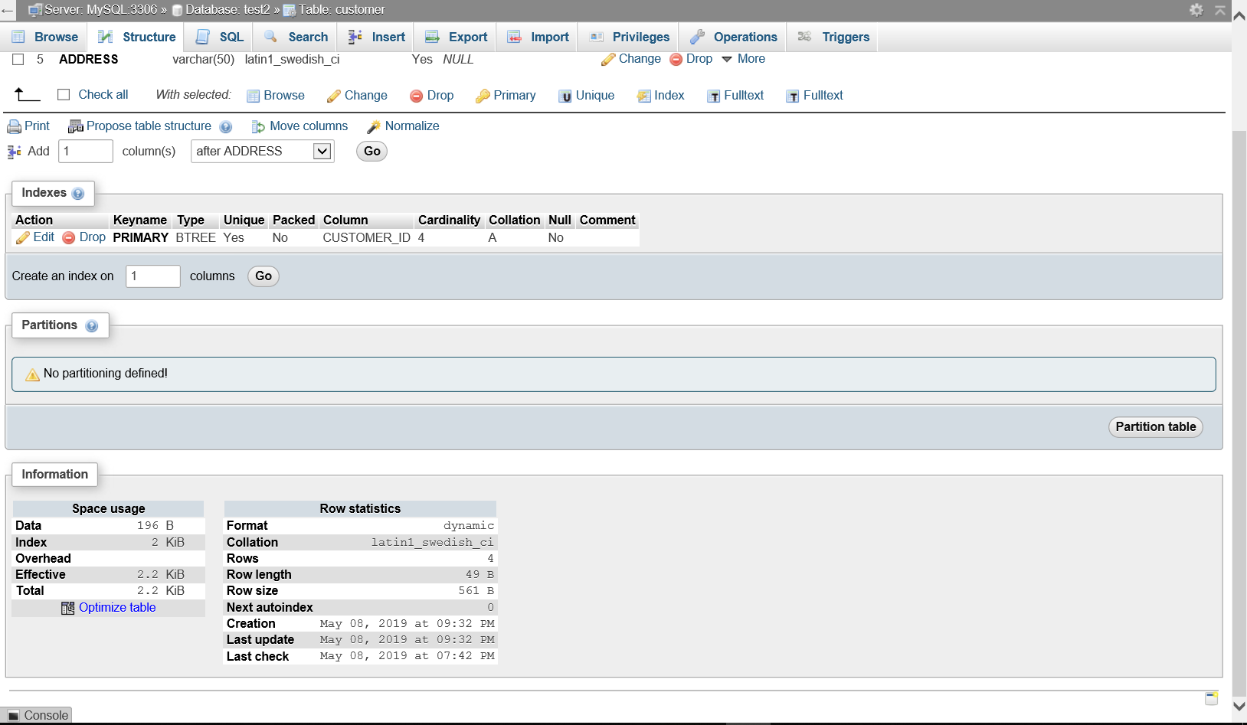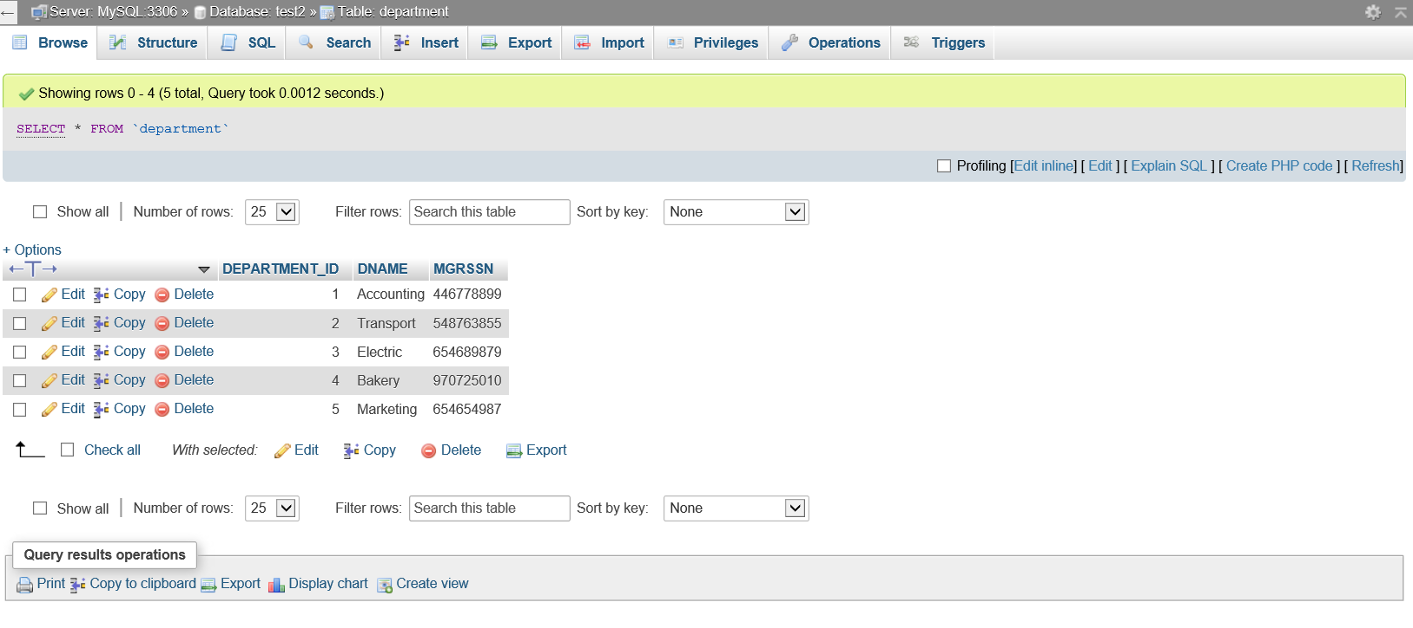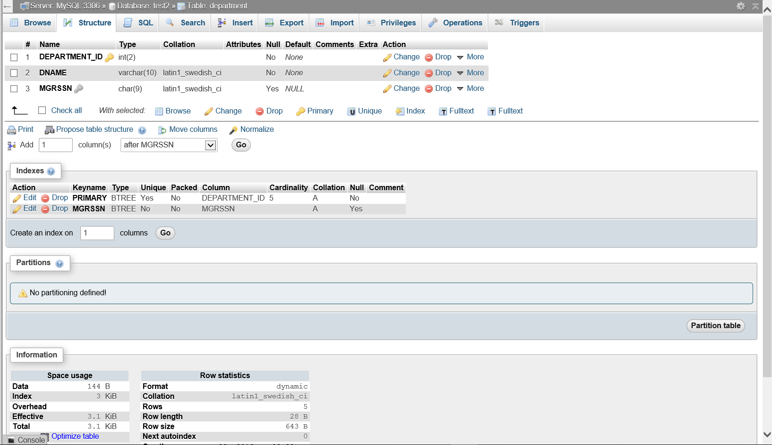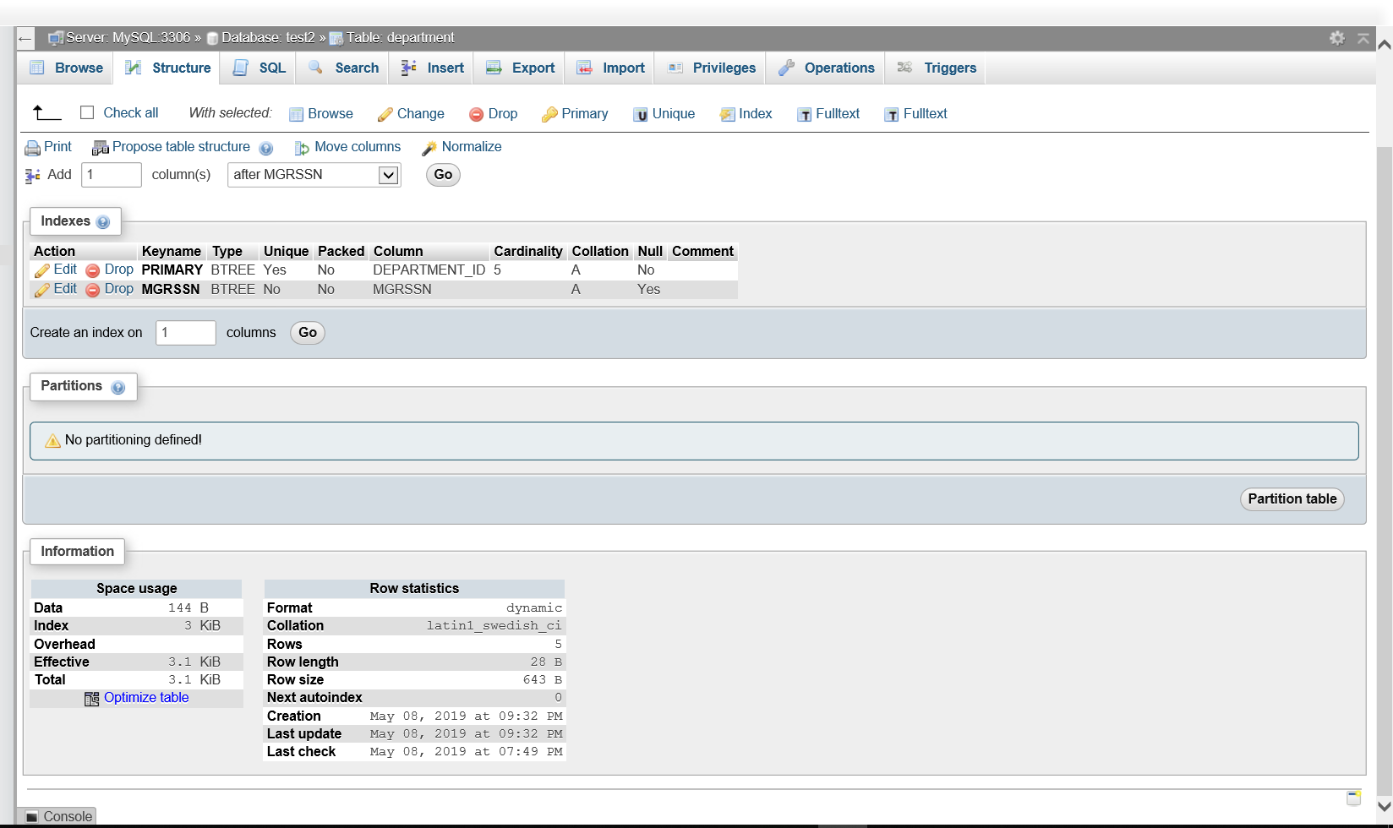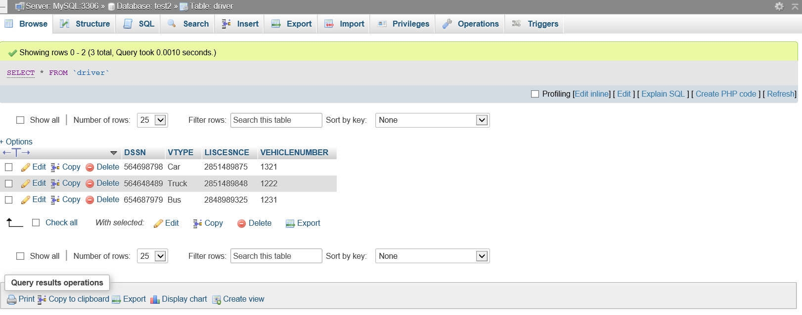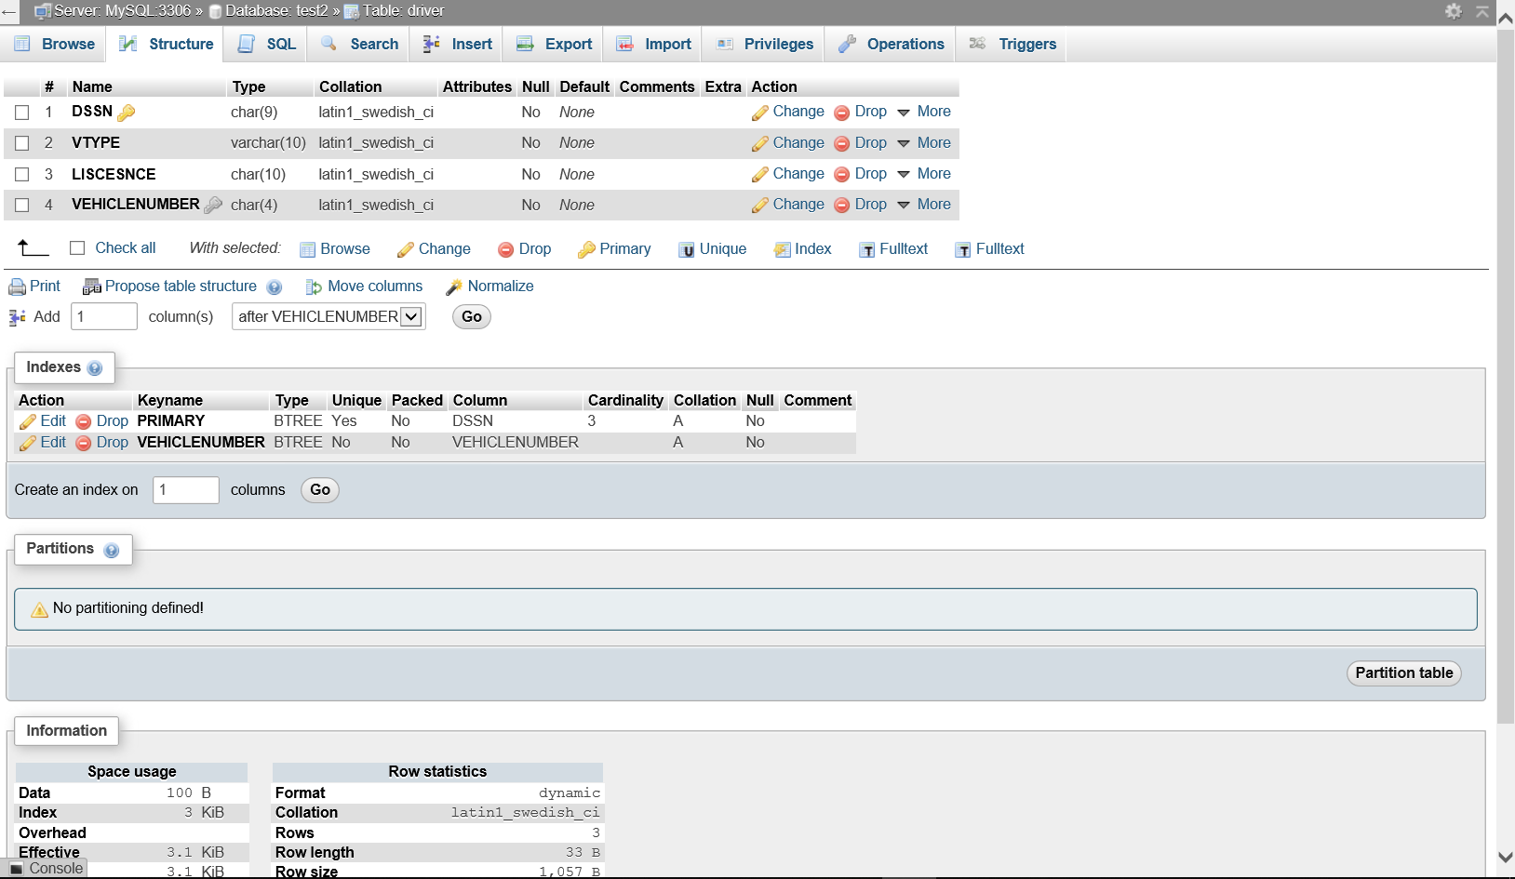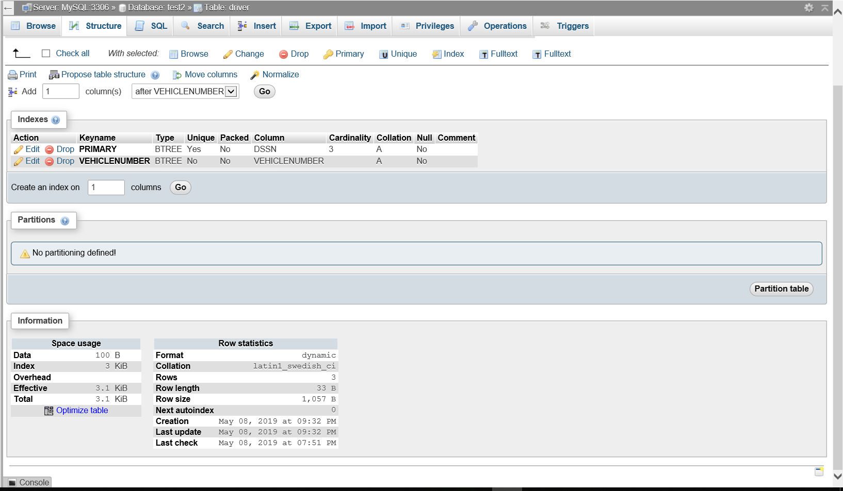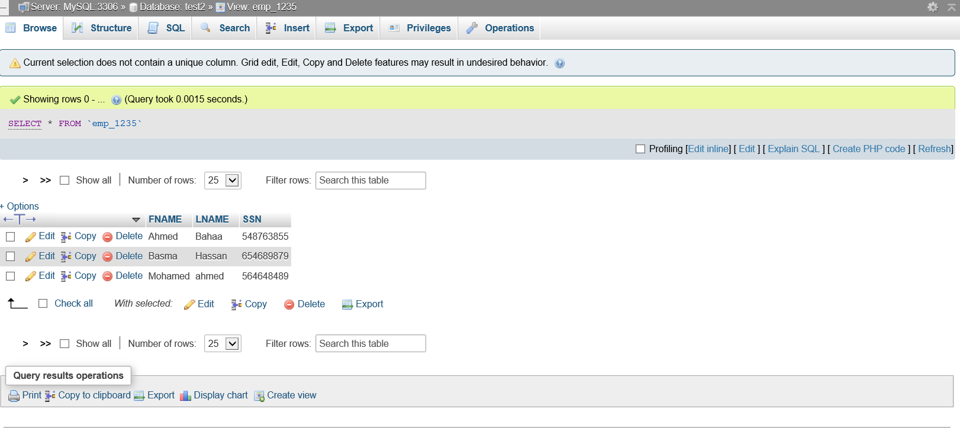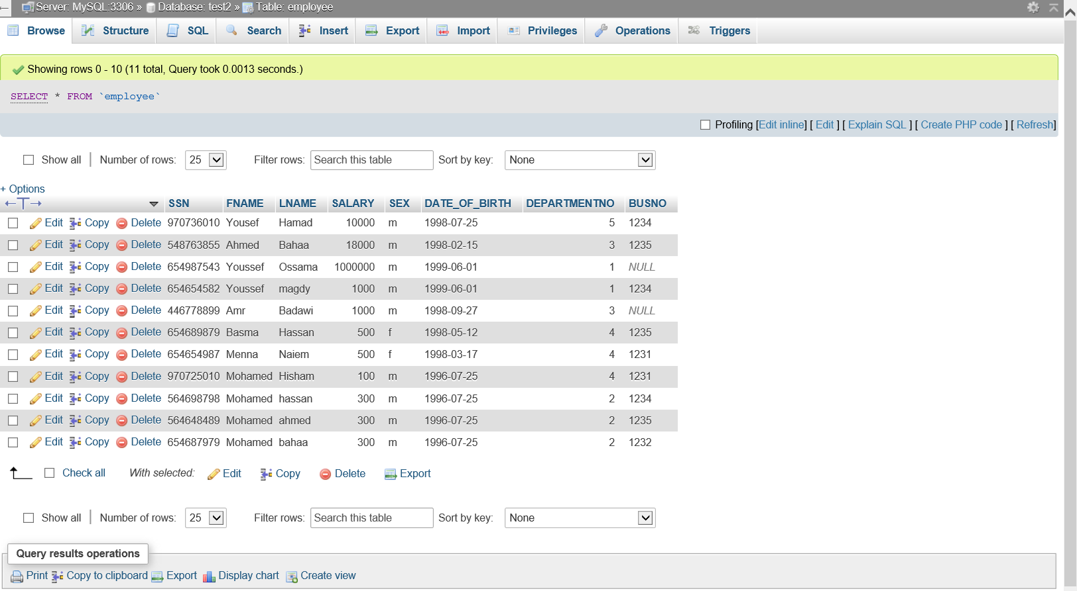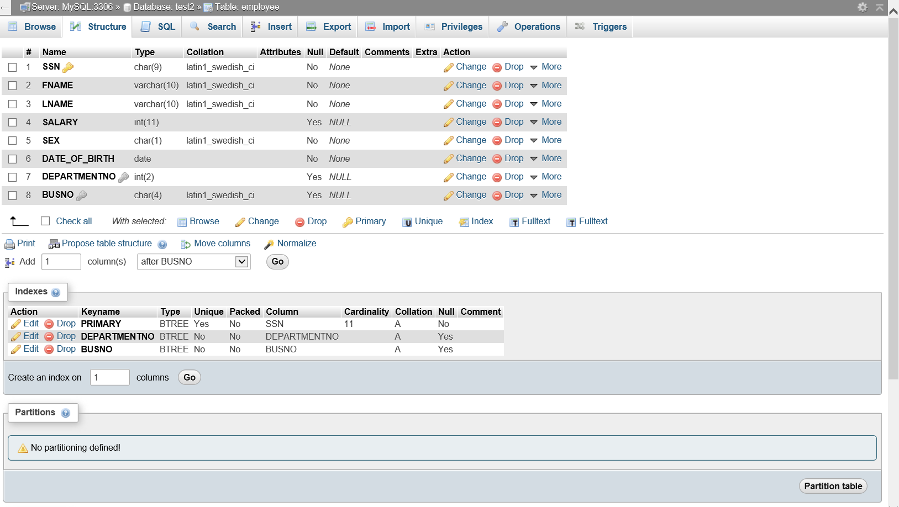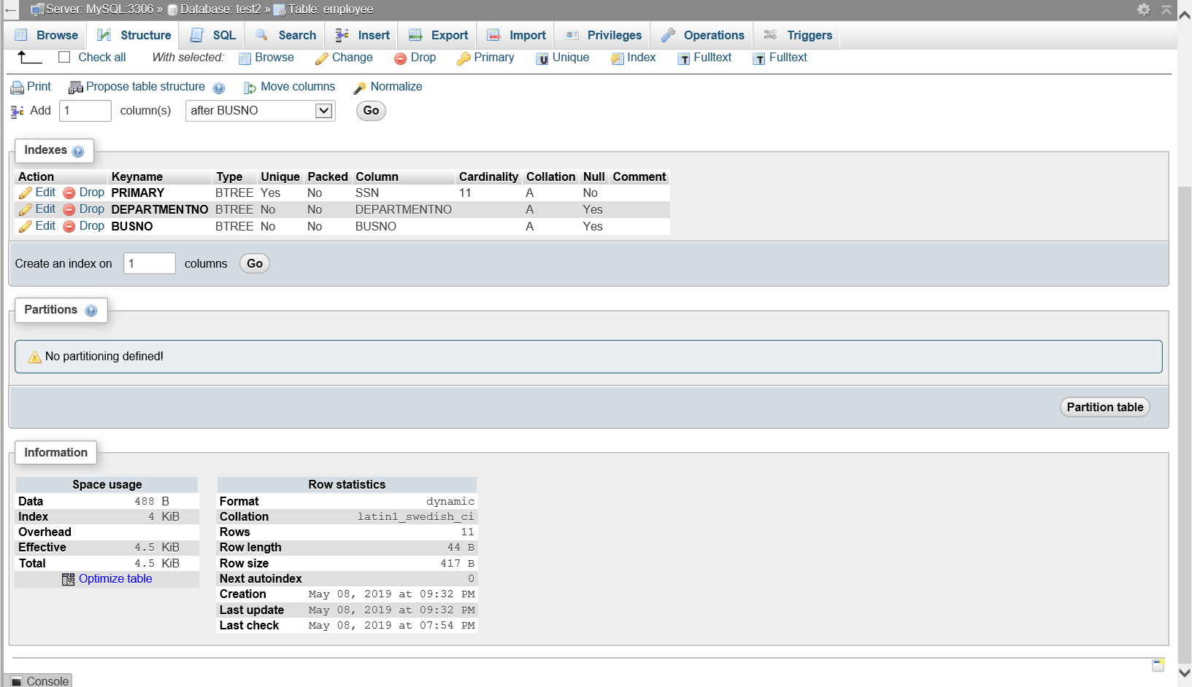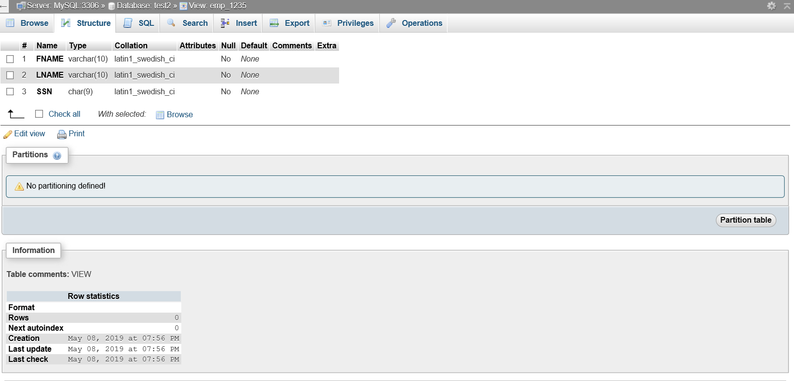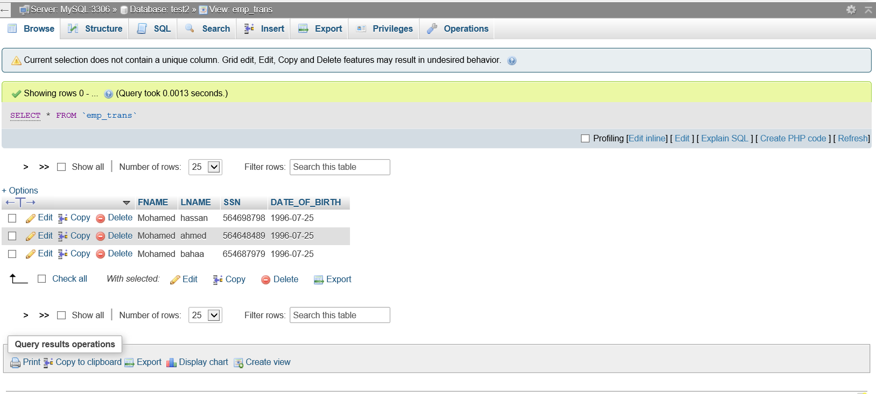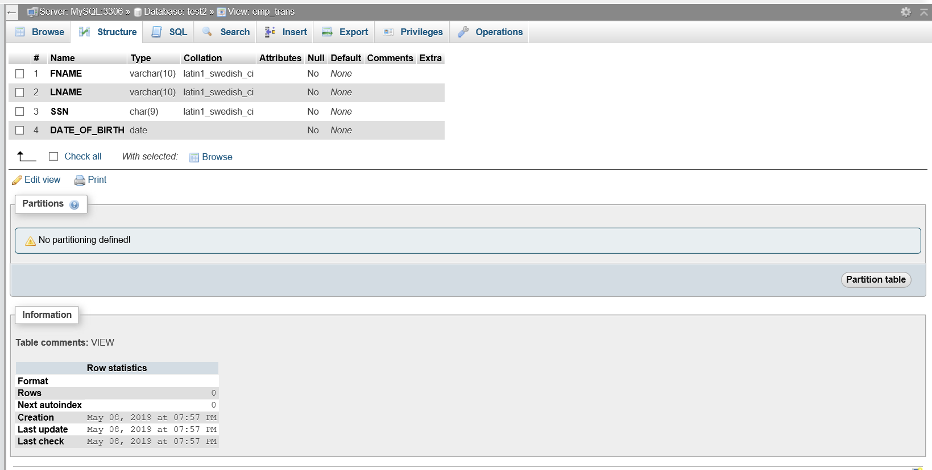

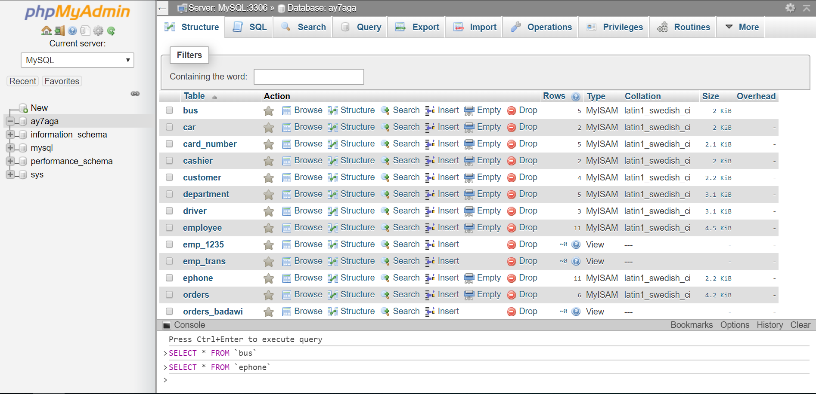

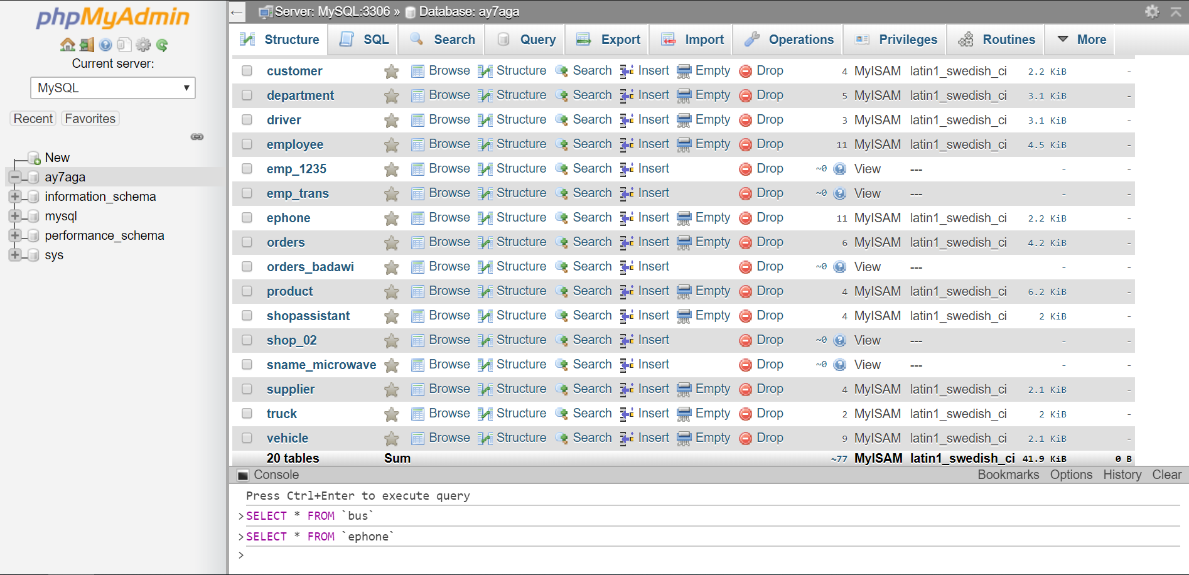

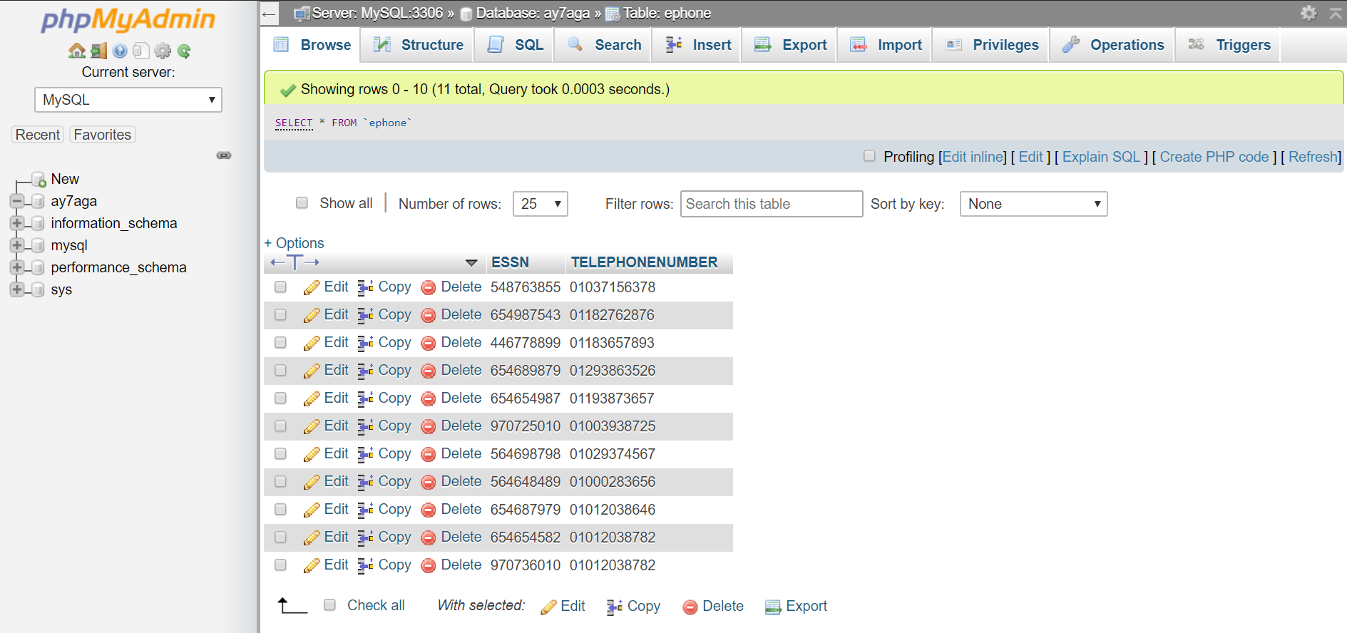

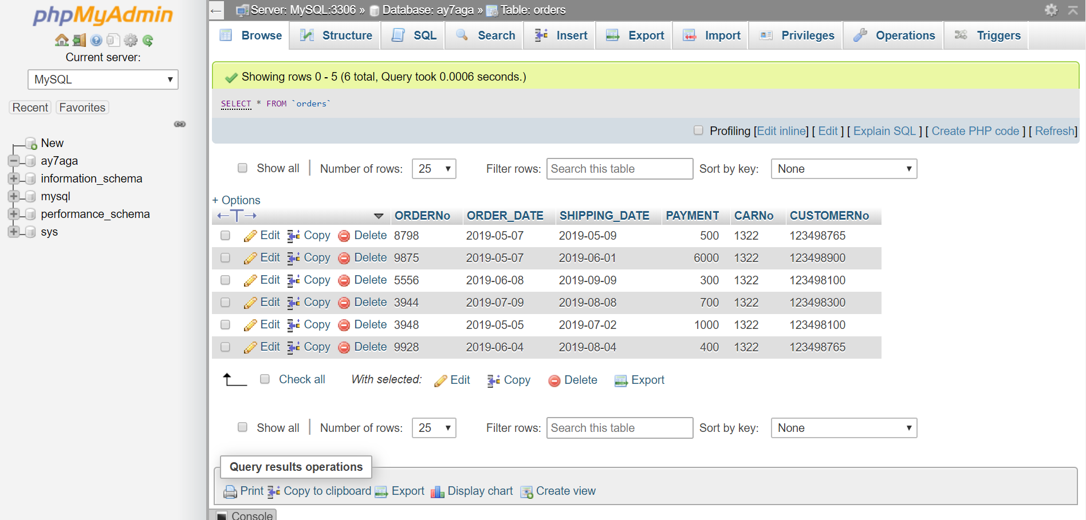

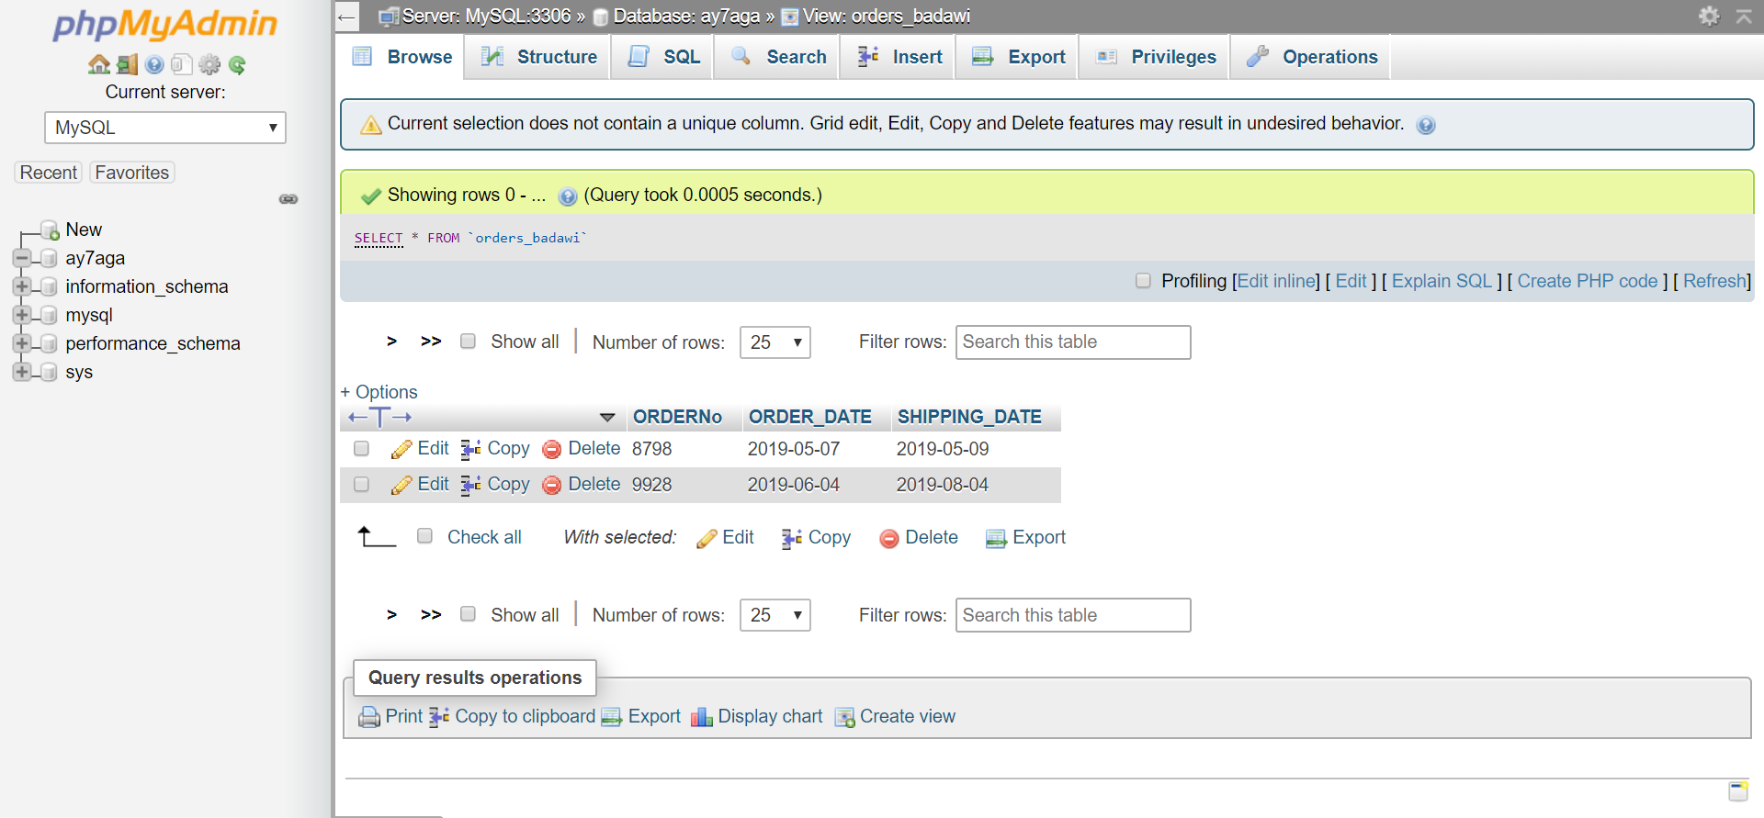

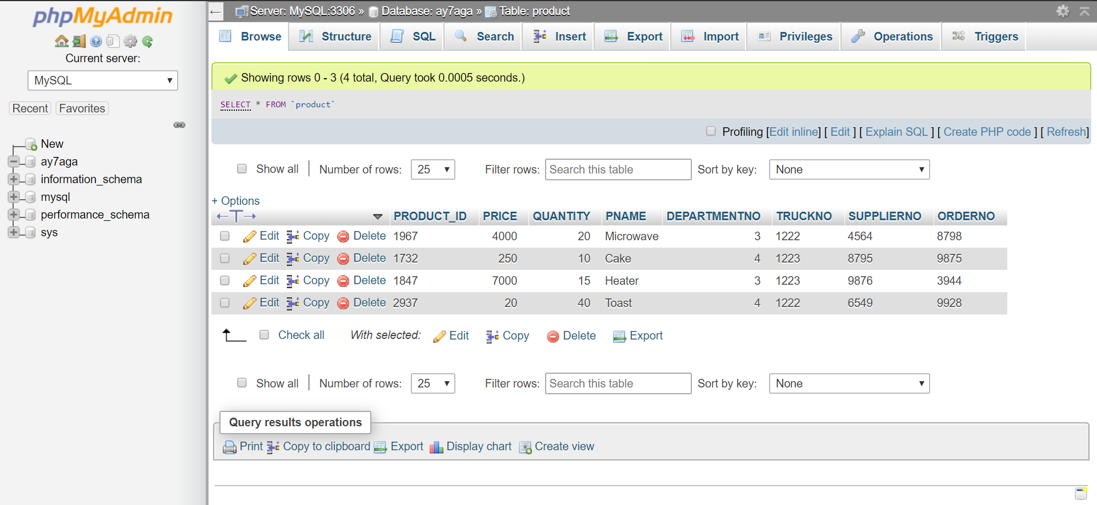

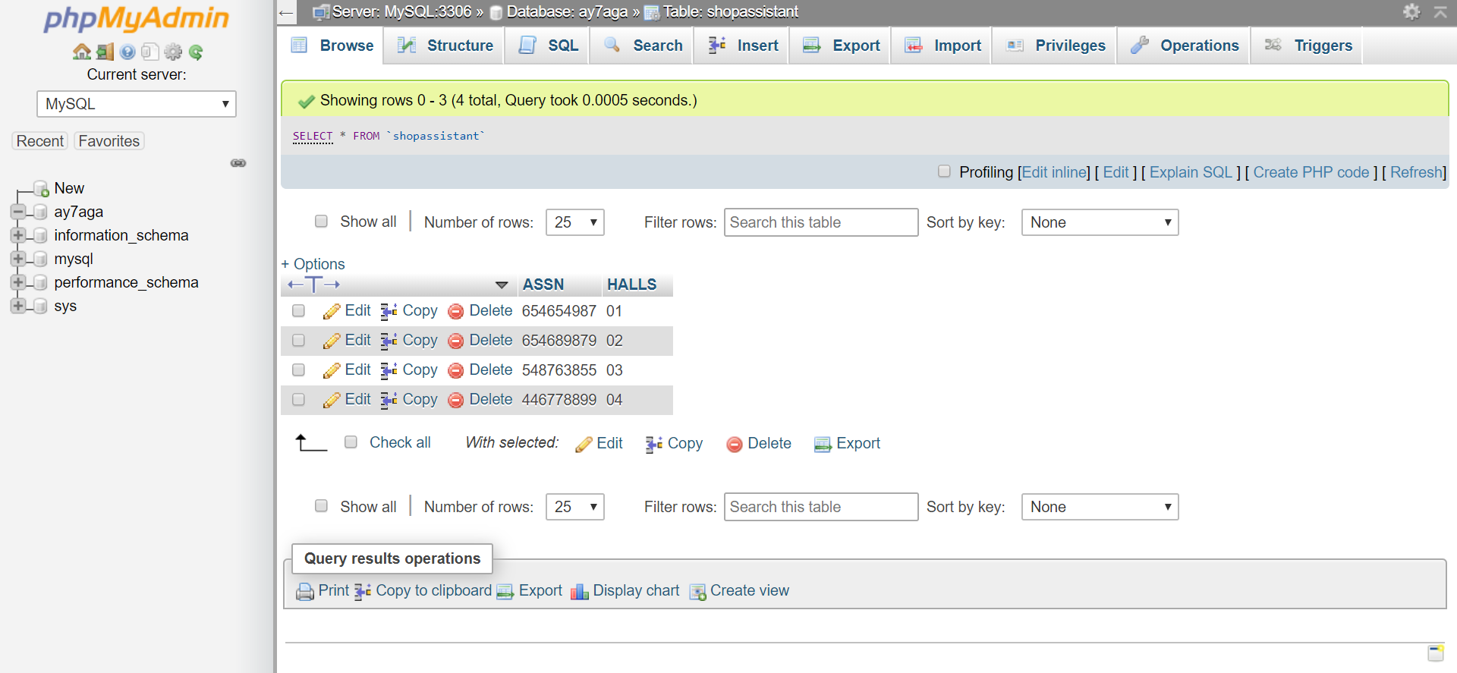

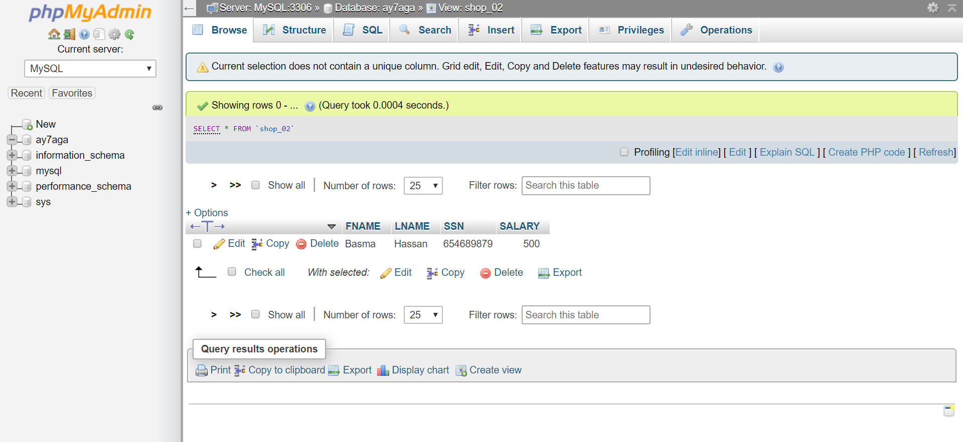

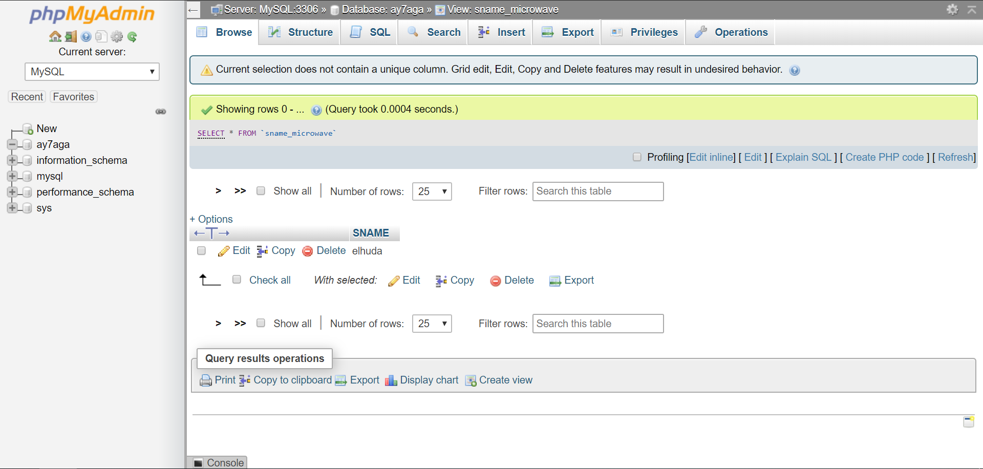

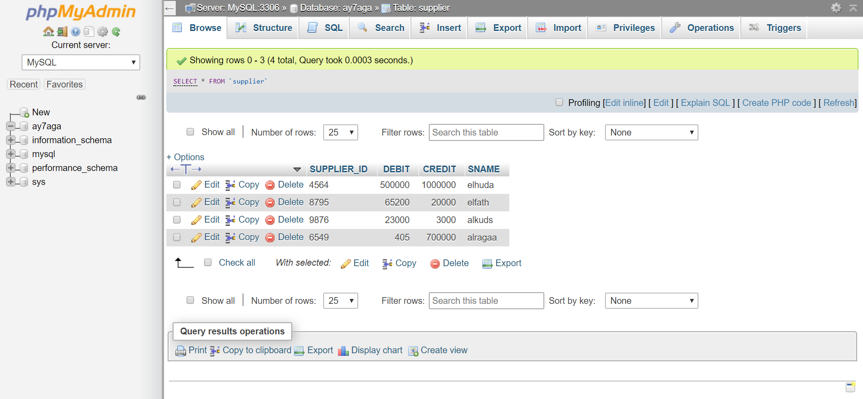

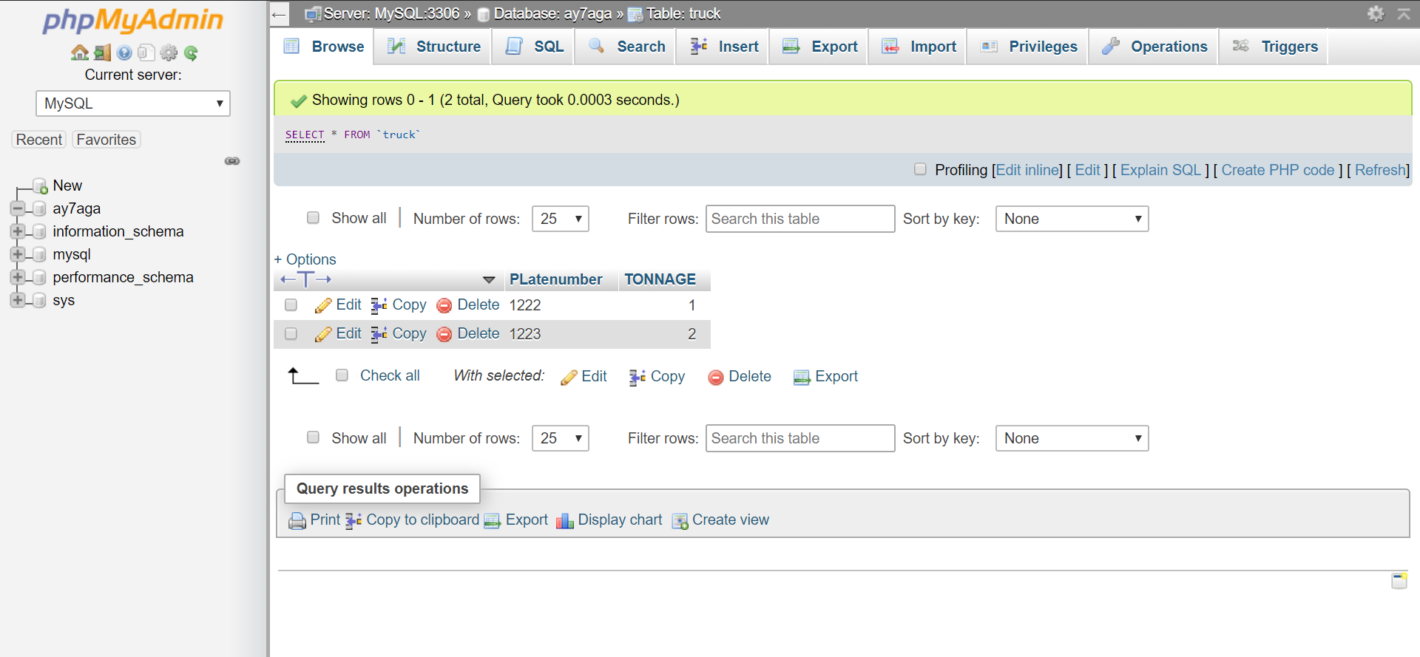

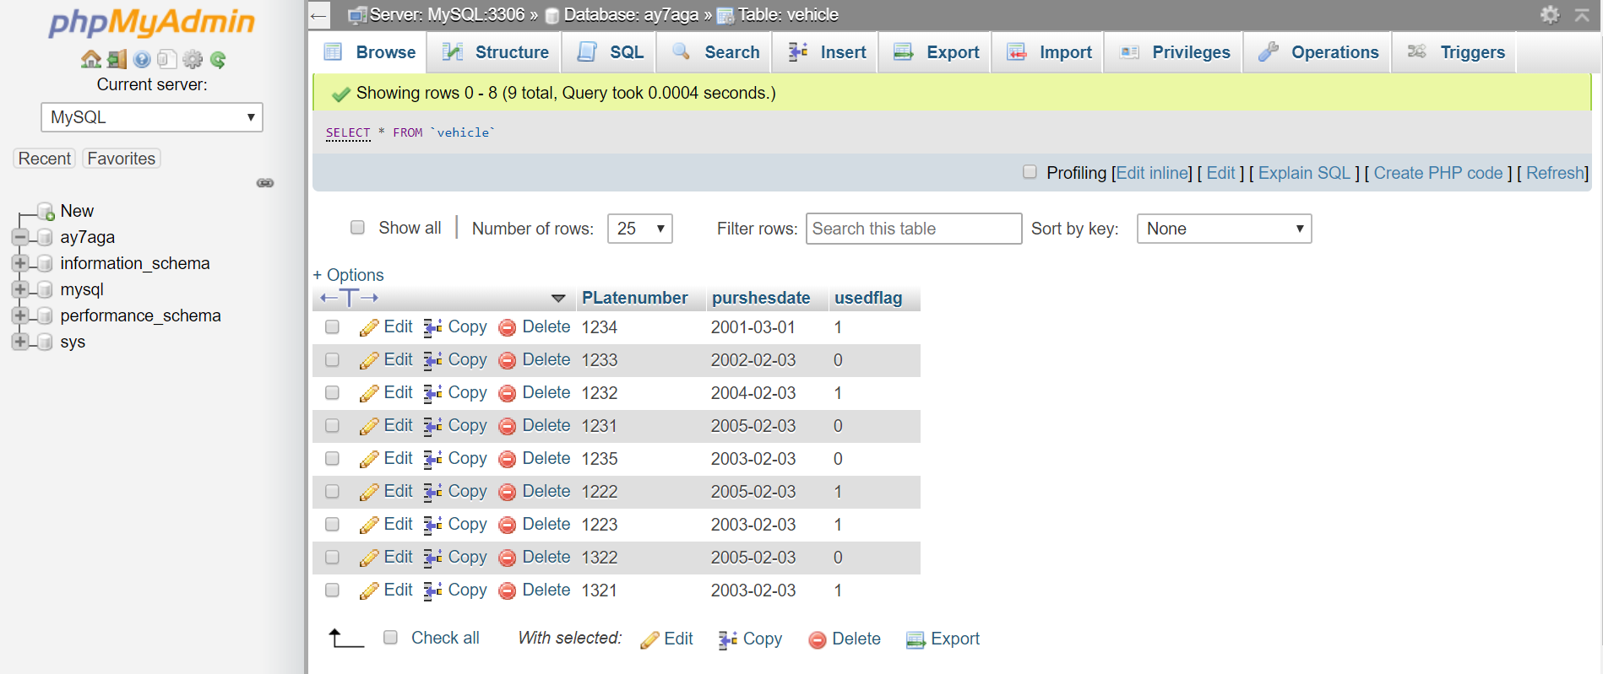

Structure:

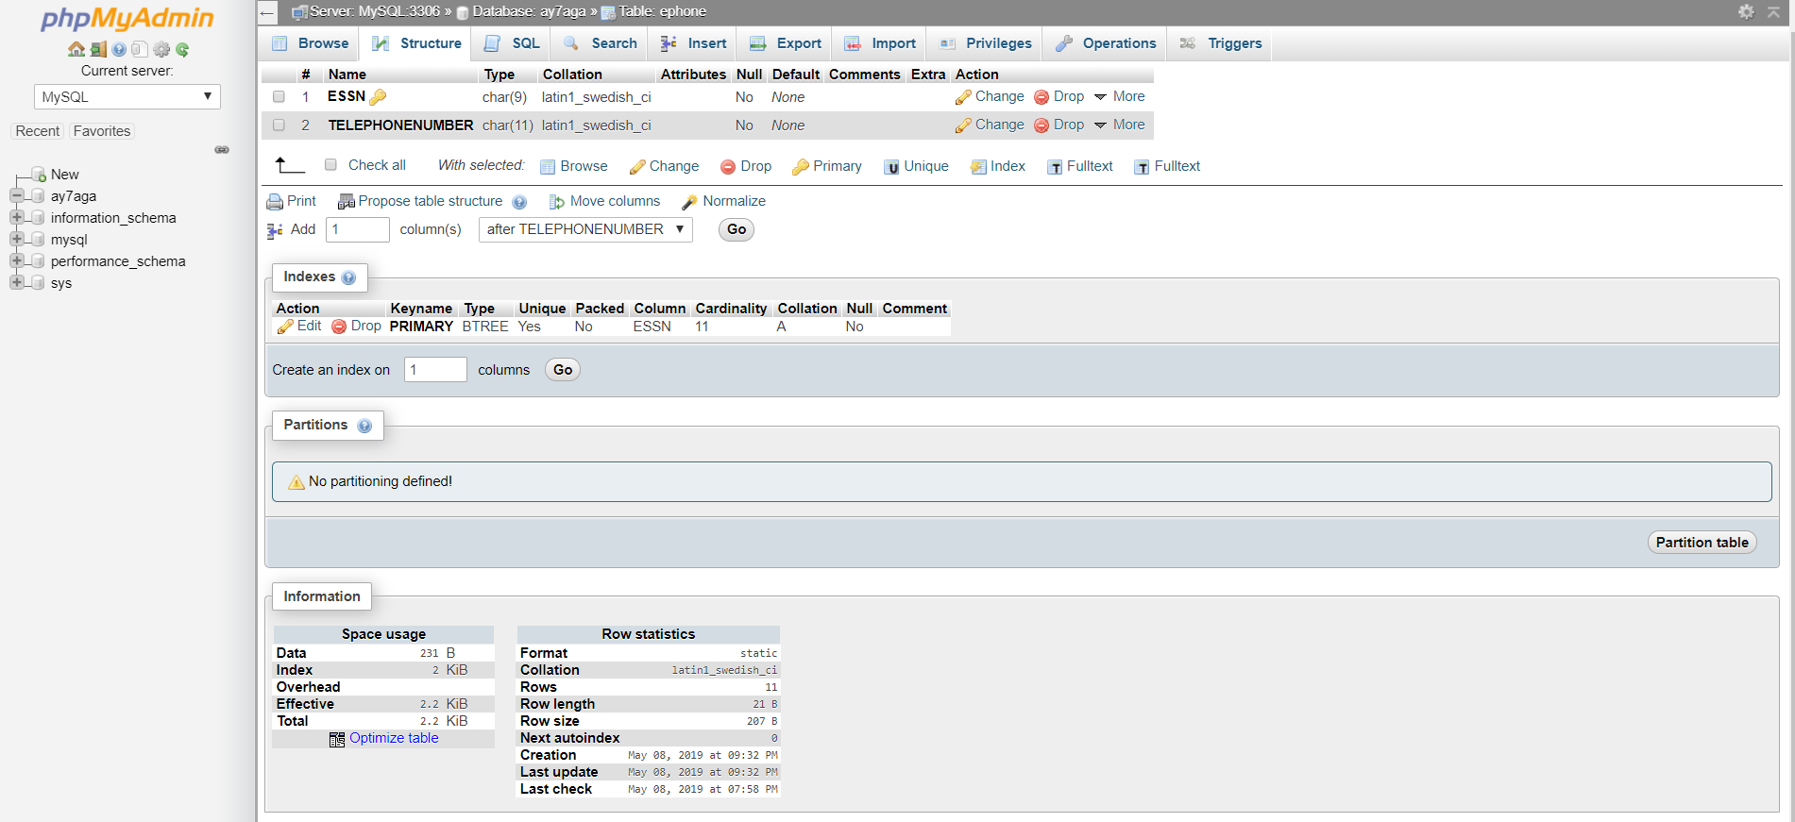

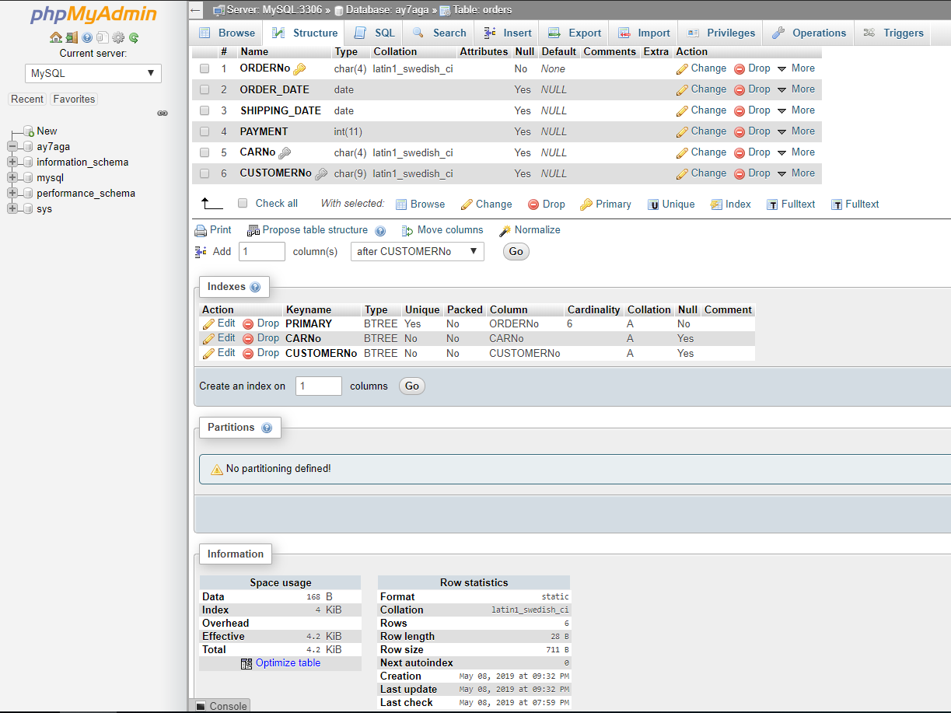

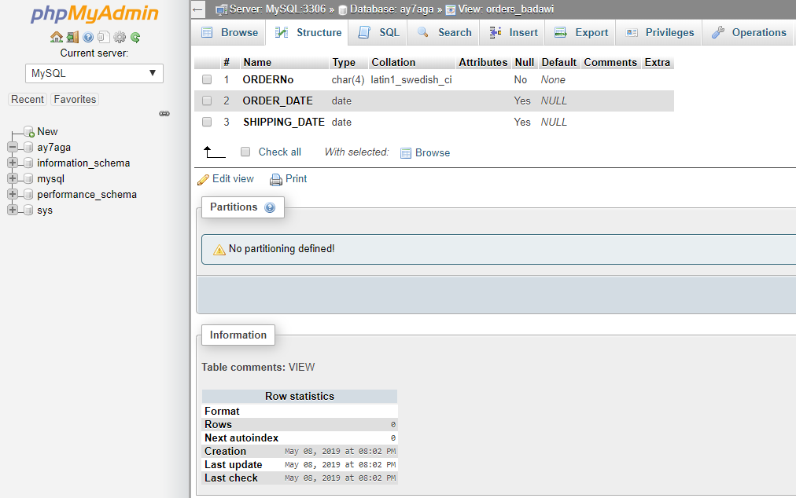

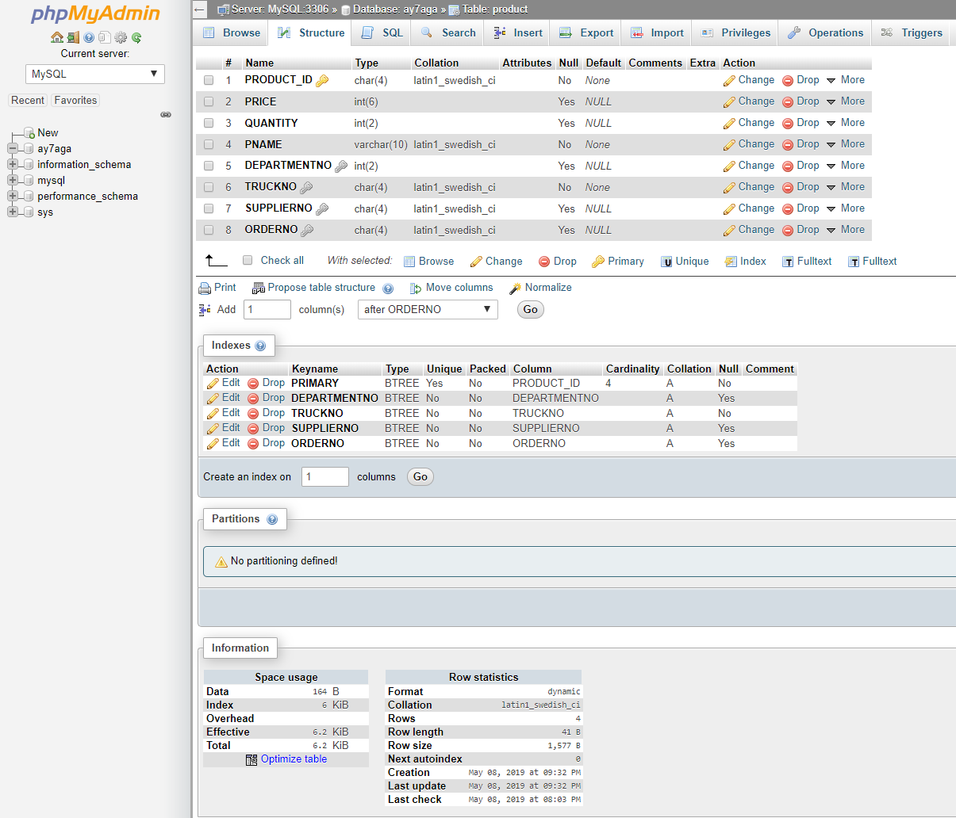

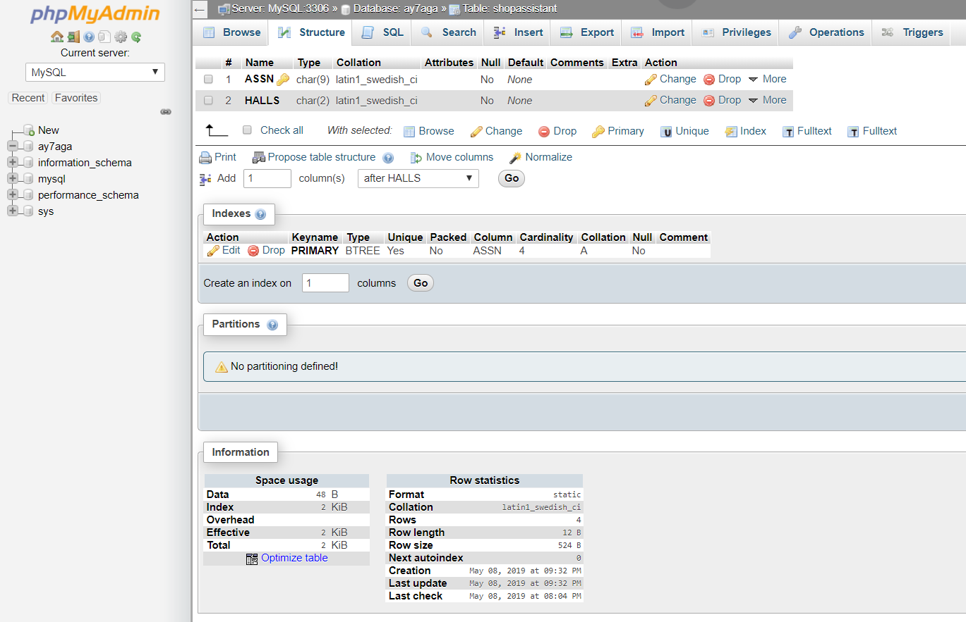

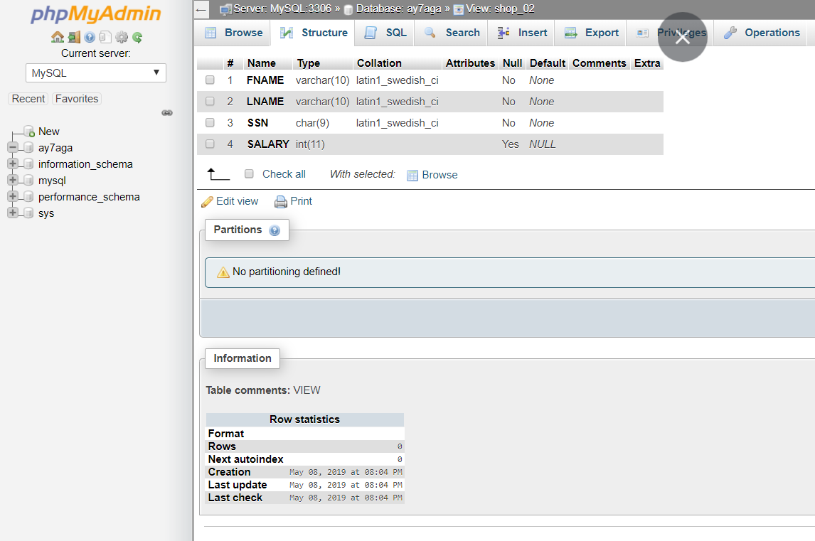

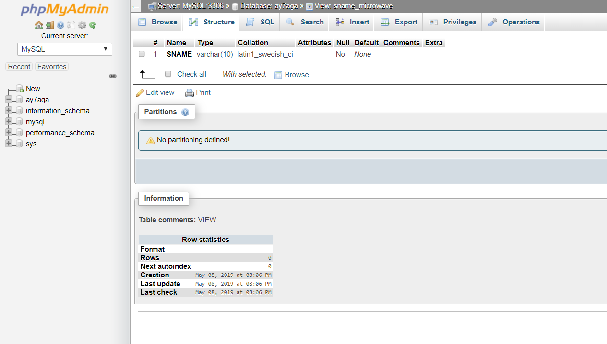

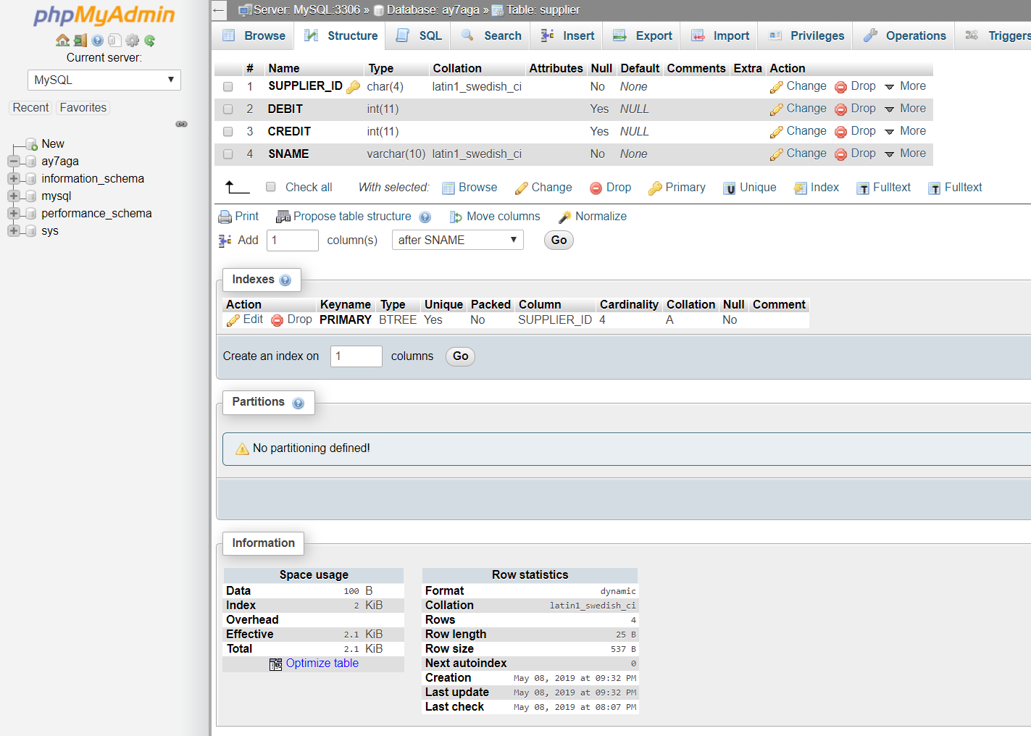

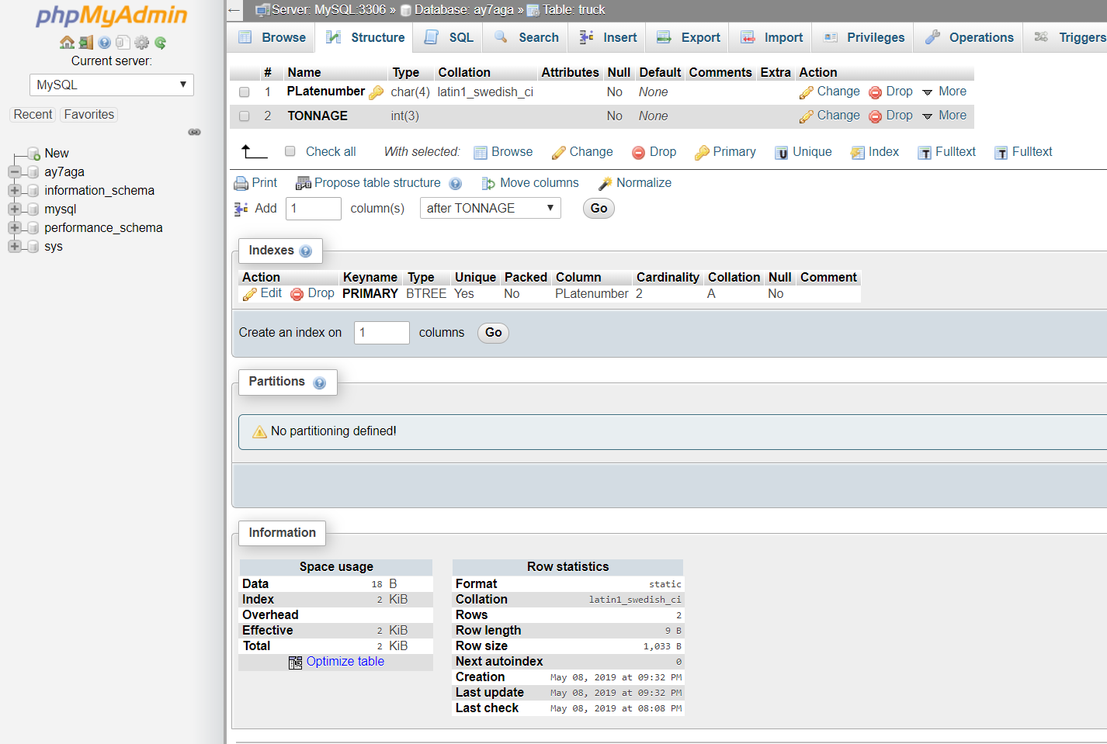

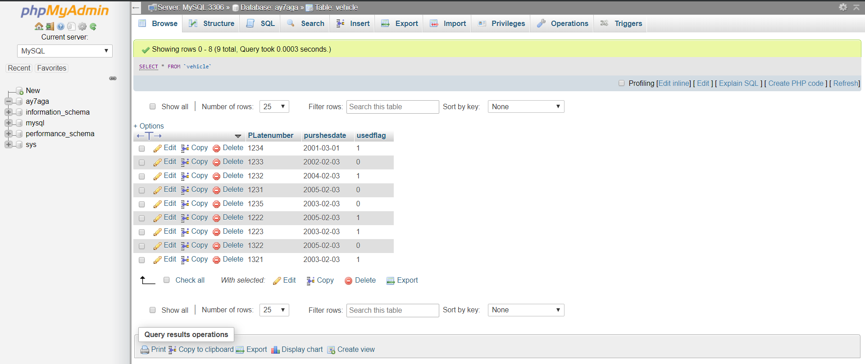

Update & Delete:

